Name: ___________________________ Date: ____________________________

UNIT 8 LESSON 10

|  |  |
| --- | --- |
| AIM: | SWBAT solve area problems involving compound figures on coordinate grids |

**THINK ABOUT IT!**

What is the area of the figure below?

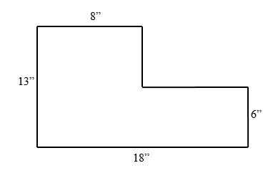

* **CFS for top quality work**
  + Problem is annotated
  + Figure is **decomposed** and dimensions are labeled
  + **Formulas** are written
  + All calculations are shown, /answer statement is written

Key Point

|  |
| --- |
| Opposite parallel sides of a rectangle are ________________. |

**Interaction with New Material**

*Ex. 1)* Edwin is retiling his bathroom using 2’ by 1’ tiles. He drew a picture of the floor of his bathroom below to help him plan. How many tiles does he need to buy to cover the entire bathroom floor?

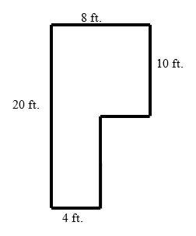

* **CFS for top quality work**
  + Problem is annotated
  + Figure is **decomposed** and dimensions are labeled
  + **Formulas** are written
  + All calculations are shown, /answer statement is written

**PARTNER PRACTICE**

* **CFS for top quality work**
  + Problem is annotated
  + Figure is **decomposed** and dimensions are labeled
  + **Formulas** are written
  + All calculations are shown, /answer statement is written

|  |
| --- |
| *Bachelor Level* |

1. Determine the area of the figure below

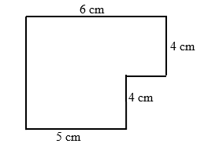

Area: ______________________________

|  |
| --- |
| *Master Level* |

1. Justin is a wedding planner. Below, he drew the floor plan of an event space that he is using for a wedding. He knows that each table takes up 9 square meters. How many tables can he fit in the event space?

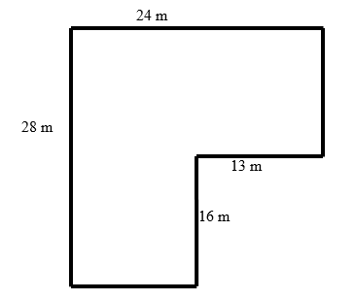

* **CFS for top quality work**
  + Problem is annotated
  + Figure is **decomposed** and dimensions are labeled
  + **Formulas** are written
  + All calculations are shown, /answer statement is written

**INDEPENDENT PRACTICE**

|  |
| --- |
| *Bachelor Level* |

1. Measure the area of the figure below.

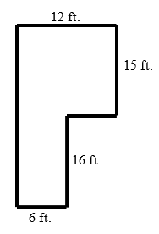

|  |
| --- |
| *Master Level* |

1. A flooring company has been hired to install wooden flooring in the living from of the Smiths’ house. A diagram of the living room is below. How many square feet of wood flooring will be needed?

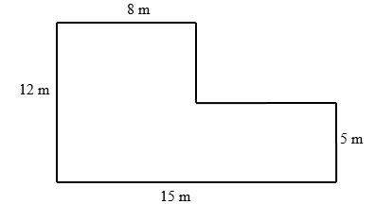

1. Patricia owns an electronics store in Clinton Hill. She wants to retile her floor to upgrade the look of her store. Below is a picture of her store’s floor.

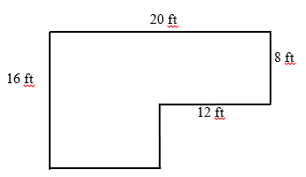

Patricia went to the store and they told her that they carry two types of tiles that have the design that she wants.

Tile:

1 sq. foot: $0.75 per tile

How much would it cost to cover the entire floor?

Answer: _________________

|  |
| --- |
| *PhD Level* |

1. A flooring company has been hired to install carpeting and flooring on the first floor of a home. A diagram of this first floor is shown.

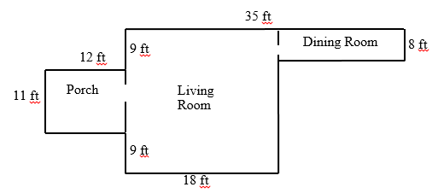

The homeowners would like to install carpeting on the porch and wood flooring in both the living room and the dining room. The company charges $1.50 per square foot of carpeting and $3.75 per square foot of wood flooring. How much will the company charge the homeowners in all?

**Name: ______________________________ Date: _______________________**

**EXIT TICKET**

|  |  |  |  |
| --- | --- | --- | --- |
| Self-assessment | I mastered the learning objective today. | I am almost there. | Need more practice and feedback. |
| Teacher feedback | You mastered the learning objective today. | You are almost there. | You need more practice and feedback. |

1. Ben wants to paint the wall of his bedroom. He drew a picture of the wall that he is painting below. How many square feet will he paint? **Show all your work**.

* **CFS for top quality work**
  + Problem is annotated
  + Figure is **decomposed** and dimensions are labeled
  + **Formulas** are written
  + All calculations are shown, /answer statement is written

5.2 ft.

5 ft.

7.3 ft.

3 ft.