Name: ___________________________ Date: ____________________________
UNIT 8 LESSON 11

AIM: | SWBAT solve area problems involving compound figures on coordinate grids

THINK ABOUT IT!
What is the area of the figure below?
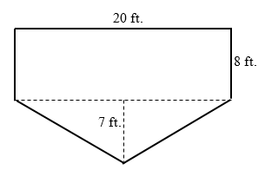

- CFS for top quality work
  - Problem is annotated
  - Figure is decomposed and dimensions are labeled
  - Formulas are written
  - All calculations are shown, /answer statement is written

Key Point
Area of ________________________ can be found by _________________ into familiar shapes.

Interaction with New Material
Ex. 1) Ms. Pettaway wants to carpet the floor of her first floor. She drew a diagram of the first floor (below). The carpet she wants to buy costs $5 per square meter. How much will it cost to carpet the entire floor?
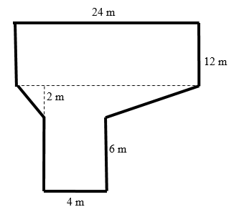
- CFS for top quality work
  - Problem is annotated
  - Figure is decomposed and dimensions are labeled
  - Formulas are written
  - All calculations are shown, /answer statement is written

PARTNER PRACTICE
- CFS for top quality work
  - Problem is annotated
  - Figure is decomposed and dimensions are labeled
  - Formulas are written
  - All calculations are shown, /answer statement is written

Bachelor Level

- Determine the area of the figure below
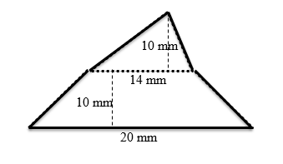

Area: ______________________________

Master Level

- The figure below represents the floor plan of Dominique’s living room and her porch. She wants to stain the floors this weekend. How many square meters will she stain if she stains the entire floor?
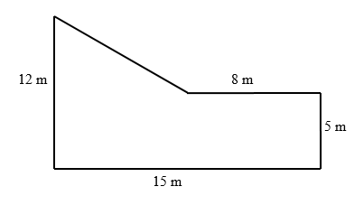

INDEPENDENT PRACTICE

Bachelor Level

- Measure the area of the figure below.
- CFS for top quality work
  - Problem is annotated
  - Figure is decomposed and dimensions are labeled
  - Formulas are written
  - All calculations are shown, /answer statement is written
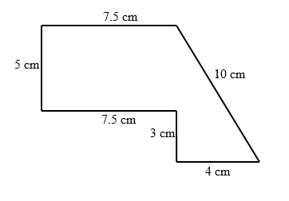

Master Level

- The picture below represents Alonso’s backyard. For his chores, he has to move the entire yard. How big is his yard in square meters?
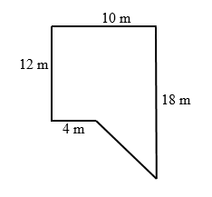

- The figure below represents a wall in Harry’s apartment. He wants to put wall paper up on the wall. Wall paper is sold in sheets of 20 square yards.

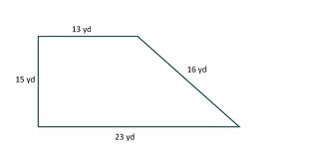

Part A: How many square yards of wall paper does Harry need to cover the entire wall?

Answer: _________________________
Part B: How many sheets of wall paper should he buy for this project?

Answer: __________________________

Part C: If wall paper costs $4.50 per sheet, how much will he spend to complete the project?

Answer: _______________________

PhD Level

- The figure below represents the floor layout of Kermit the Frog’s mansion. He wants to place gold carpeting over the entire floor. Gold carpet is sold in rolls of 10 square feet and costs $350 for each roll. He has a discount coupon of $10 off per roll. How much will it cost Kermit to re-carpet his entire mansion?
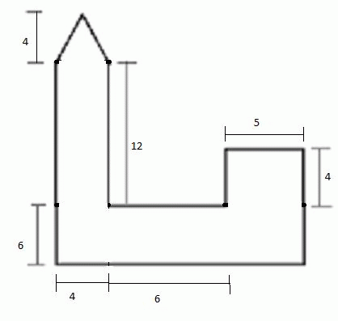

Name: ______________________________ Date: _______________________
EXIT TICKET
Self-assessment | I mastered the learning objective today. | I am almost there. | Need more practice and feedback.
Teacher feedback | You mastered the learning objective today. | You are almost there. | You need more practice and feedback.

- David is the groundskeeper at a Triangle Park shown below. During the winter, the triangular park and adjacent square parking lot are flooded with water and allowed to freeze so that people can go ice skating. What is the area of the ice?

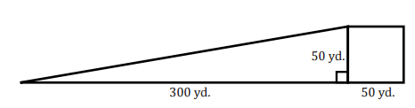
- CFS for top quality work
  - Problem is annotated
  - Figure is decomposed and dimensions are labeled
  - Formulas are written
  - All calculations are shown, /answer statement is written

50.5 yds.
350.5 yds.

