Grade 7 | Unit 5, Lesson 14

Intellectual Preparation Cover Sheet

Directions: Complete the IPP Cover Sheet for every lesson due for submission.
Step | Action:
- Understand the concept and/or big ideas at play in the lesson and be able to articulate them clearly and crisply. | - Read the entire Lesson Plan and identify the key concepts/big ideas students need to understand. Create a lesson summary annotation that describes, in your own words, the purpose of the lesson (why), the key concepts students need to understand (big ideas/what), and how they will come to understand these within the lesson.
- Do the core tasks of the lesson to develop/refine exemplar work and clear CFS for anticipated strategies. | - Print the classwork and complete this step directly in the student packet for the TAI, INM/TTC problem (include exemplar annotations), and all GP/IP problems.
- Anticipate misconceptions and create questions/supports to address these misconceptions. | - For each core task, annotate to describe expected errors on the tasks and back pocket questions to respond to these errors  - Identify the questions in the TAI debrief and INM/TTC that elicit the most important understandings and annotate with the following:  - The exemplar student responses  - 1-2 misconceptions or errors that could surface in response to these questions  - BPQs and/or the instructional strategy to address these misconceptions.
- Optional/As needed: Adjust the plan for any individualized AOTY or intellectual preparation goals. | - As determined with coach, you might:  - Script MVP directions into lesson plans  - Script in additional planned investment moves  - Create rapid & batched feedback forms to capture data  - Determine additional points for differentiation (especially for very high and very low performance during the lesson)  - If you will meet in person to scrimmage this lesson, your coach may also ask you to submit a proposed practice objective and identify the lesson segment to practice.
Submit annotated plans and any additional work as per IPP expectations in soft copy of LPs to your coach weekly (and at least 48 hours in advance of the IPP meeting). Implement any feedback from coach prior to the phase 2 meeting.
- Rehearse and Refine:
  - Meet with coach to further internalize and practice executing the plan. Refine plan as needed.
  - Refine plan as needed based on practice and/or student exit ticket data.
  - If possible, prior to teaching the day of, analyze student work from TAI administered at end of CR block; select S work to show call to drive TAI debrief discussion to land Fence Posts and key point.

Lesson Type: Conjecture Based Lesson
Aim
- SWBAT explore, understand and explain the effect of scaling on the area of a figure.
Conjecture
- Scale factors do not apply to area
Standard
7.G.1
Solve problems involving scale drawings of geometric figures, including computing actual lengths and areas from a scale drawing and reproducing a scale drawing at a different scale.

State Test Alignment
Taken From Previous AF IA – No Aligned State Released Problems
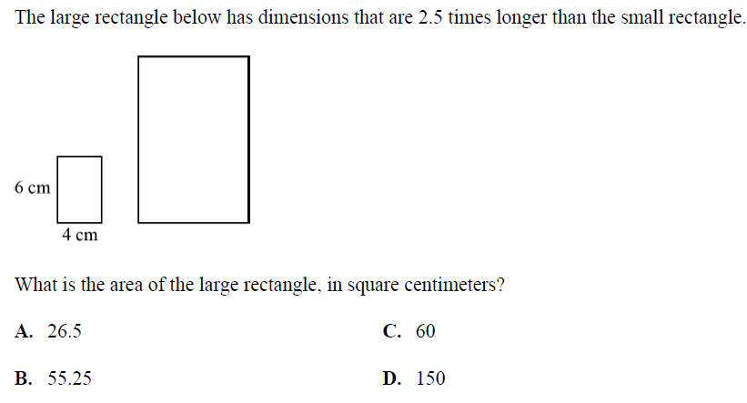

Assessment
Exit Ticket:
- Square A has a side length of 6 cm. Square B is the resulting image after a scale factor of 2 has been applied to Square A. Shania says that the area of Square B is 2 times the area of Square A. Determine the area of Square B. Do you agree with Shania? Explain why or why not. If you disagree, describe the correct relationship between the two areas.

Student Work:
- Square A:
Area = s² = 6² = 36cm²

Square B:
Side length = 2(Square A) = 2(6) = 12
Area = s² = 12² = 144cm²

I disagree with Shania because the area of square A is 36cm² and applying a scale factor of 2 would make it 72cm². However, the scaled side length of square B is 12 so the area is 144cm²
Connection to learning And Conceptual Understanding
- How does this lesson connect to previous lessons?
  - In the previous lessons, students have been working with scale factors and drawings to determine missing lengths given a scale factor or a scale within the context of a problem. In this lesson, students apply scaling to figures and compare their areas. While it would seem intuitive that if a scale factor of 3 is applied to a figure, the area of the scaled figure would also scale by 3, the area actually scales by r² where r is the scale factor (note to teacher – students do not formally express this until the next lesson). In this lesson, students calculate areas of figures and apply scale factors to create new figures and calculate their area to verify that the scale factor cannot be directly applied to determining the area of a scaled figure.
- What do we want every student to take away or do as a result of this lesson? How will a teacher know if students have met this goal?
  - Understand: Students understand that the same scale factor used to create a scaled drawing of a figure cannot be directly applied to determining the area of a scaled figure because area has two dimensions and the scale factor alone only applies to one dimension.
  - Do: Students determine the dimensions of a scaled figure given a diagram and scale factor. Students calculate the area of a scaled figure by applied the correct formula for area.
How
- Key Strategy
  - Determine the scale factor (if needed)
  - Draw the scaled figure with correct scaled side lengths
  - Determine the area of the figure given the formula for area

- CFS for top quality work
  - Scale factor is annotated
  - Scale drawing is labeled with scaled side lengths
  - Work for area is shown with given formula
Anticipated Misconceptions and Errors
- Students might try to directly apply the scale factor to the area of the original figure.
- Students might not correctly determine the scaled side lengths
- Students might misapply the given area formulas
- Students might not recall area formulas required to be memorized
Key Vocabulary
- Constant of Proportionality: the constant value of the ratio of two proportional quantities x and y; usually written y = mx or y = cx, where m and c are the constant of proportionality
- Scale drawing: A magnified or reduced drawing of an object that is similar to the actual object.
- Scale factor: The ratio that compares a length in a drawing corresponding to the length in another magnified or reduced drawing.
- Ratio: A comparison of two quantities by division.
Materials
- Handout

Opening – Prompt for work time, Circulate, Debrief, Synthesis, & Frame – 12-15 min
THINK ABOUT IT!
Rectangle A had a scale factor of 3 applied to it to create Rectangle B. Use the scale factor to determine the area of Rectangle B
Prompt for Work Time (<30 sec)
      - T sets timing for work and sets work expectations.

Circulate (≤ 5 min)
      - While circulating, collect data on the following:

Scholar thinking (correct and erroneous) | Scholar Initials - Work to show call
S determines the area of rectangle A and multiples by 3
S determines the scaled dimensions of rectangle B and multiply them to find the correct area
S does not correctly apply the scale factor to determine the side lengths of rectangle B.

Debrief (≤ 8-10 min)
      - Fencepost 1: The measure of a scaled side length is the original side length multiplied by the scale factor
        - Show Call: S determines the scaled side lengths and multiply to find the correct area.
        - How did the scholar determine the side lengths? CC. SMS: Scaled figures and drawings have proportional side lengths so the scale factor can be multiplied by each side length to get the new scaled side length.
        - Name the fencepost: How do we find scaled side lengths? SMS: The measure of a scaled side length is the original side length multiplied by the scale factor.

      - Conjecture: Scale factors do not apply to area
        - Show Call: Keep up the first Ss work and also show S who finds the area of Rectangle A and multiplies by 3.
        - Describe the first scholar’s strategy. CC. SMS: This scholar applied the scale factor of 3 to determine the dimensions of Rectangle B and then multiplied the length by the width to get the area.
        - Describe the second scholar’s strategy. CC. SMS: The scholar determined the area of rectangle A by multiplying the length and width to get 15cm². Then they applied the scale factor of 3 like you would to determine the scaled side lengths and multiplied 15 by 3 to get 45cm² for the area of Rectangle B.
        - What do you notice? CC. SMS: The area is not the same as the first scholar’s work.
        - Which scholar was correct? TT. CC. SMS: The first scholar has to be correct because we know that the sides of scaled figures are proportional and that you can calculate them my multiplying the original side length by the scale factor. Because we know this is true, the area we calculated with the correct side lengths must be the correct answer and 45cm² must be an incorrect answer.

Key Learning Synthesis (≤ 2 min)
      - CONJECTURE: Scale factors do not apply to area
      - Let’s form our conjecture for today. With your partner, come up with a conjecture about scale factors and area of figures.
      - Note to teachers – This is the first conjecture that is worded negatively and students might struggle with the language or try to create a conjecture that is overly verbose trying to explain the steps for finding the area given a scale factor like in Fencepost 1.

Frame (≤ 30 sec) –
You have just formed our Conjecture for today. This is the first time that we have had a negatively worded conjecture. This is because it would seem intuitive that if the scaled side lengths of figures can be determined by simply multiplying the original side lengths by the scale factor, then so must the area. We have seen that this is not the case and that the scale factor cannot be directly applied to determine the area of a scaled figure meaning that the areas of scaled figures are not proportional and we must apply scale drawings to determine side lengths to calculate area.

Test the Conjecture – 10 min
Post the Conjecture in visible place for student reference: Scale factors do not apply to area

Let’s go ahead and test our conjecture to make sure that it is a true statement all the time!
What will we be able to do if our conjecture is true? TT. CC. We will not be able to apply scale factors to area, but rather to individual dimensions.

TEST THE CONJECTURE #1
Circle B is created by applying a scale factor of ½ to Circle A. Determine the approximate area of Circle B using 3.14 for pi.
- Take 30 seconds to read and annotate the problem.
- What is the question asking us to do? CC. SMS: The question is asking us to find the approximate area of Circle B using a scale factor.
- How can we apply our conjecture to solve the problem? CC. SMS: We know that we cannot simply multiply the area of circle A by the scale factor so we must determine the scaled length of the radius and find the area using that length.
- How do I determine the scaled length of the radius? CC. SMS: The scaled length is equal to the original length multiplied by the scale factor which is 16(1/2) = 8.
- What do we do next? CC. SMS: We have to use the area formula of a circle which is a=πr² where r is 8 and we are using 3.14 for pi to find an approximate area.
- Independently determine the area of circle B. Show Call exemplar. Do you agree with this work? CC. SMS: Yes I agree with this work because 8 x 8 x 3.14 is 200.96.
- How can we prove that our conjecture worked? SMS: We can determine the area of circle A and multiply it by ½. The answer should be different.
- Independently check if the area scales the same as the side lengths. Show Call exemplar. Do you agree with this work? CC. SMS: Yes I agree with this work. The approximate area of Circle A is 803.84 and half of that is 401.92.
- So far, does our conjecture hold up? Vote. CC. SMS: Yes, our conjecture holds up. The scale factor applied to the individual dimensions, not the area.

TEST THE CONJECTURE #2
The two triangles below are scaled figures. Determine the area of the larger triangle.
- Take 30 seconds to read and annotate the problem.
- What is the question asking us to do? CC. SMS: The question is asking us to find the area of the larger triangle.
- What is different about this problem? CC. SMS: We are not given the scale factor and have to determine it to find the length of a missing side.
- How can we apply our conjecture to solve the problem? CC. SMS: We can determine the scale factor to find the measure of the missing dimension and then use the area formula for a triangle which is a=1/2bh to find the area.
- With your partner, determine the scale factor and determine the length of the missing side. Teacher can walk scholars through this if they are struggling with the concept/skill.
- Show Call Exemplar: What does 1.5 represent? CC. SMS: 1.5 is the scale factor that is applied to the smaller triangle to produce the larger triangle. We can multiply 12 by 1.5 to determine the missing corresponding side which is 18.
- What do we do next? CC. SMS: We substitute the values of the base and height into the area formula to determine the area of the larger triangle.
- Independently determine the area. Show Call exemplar. Do you agree with this work? CC. SMS: Yes I agree with this work because 12 x 18 x ½ = 108.
- How can we prove that our conjecture worked? CC. SMS: We can determine the area of the smaller triangle and multiply it by the scale factor 1.5 to see if it produces the same area. It should not.
- Independently check if the area scales the same as the side lengths. Show Call exemplar. Do you agree with this work? CC. SMS: Yes, I agree with this work. 12 x 14 x ½ = 84, and 84 x 2 = 168, which is NOT the area of the larger triangle.
- So far, does our conjecture hold up? Vote. CC. SMS: Yes, our conjecture holds up. The scale factor applied to the individual dimensions, not the area.

Stamp the Learning
      - Point to the written conjecture. Did our conjecture hold up against the two problems we just did? How do you know?. Vote. TT. CC. SMS: Yes, our conjecture holds up. The scale factor applied to the individual dimensions, not the area.
      - STAMP THE CONJECTURE

Frame for PP/IP
      - For the next 5 minutes, you’ll be working with your partner applying the conjecture that we just stamped. While working, make sure that you are meeting our CFS for top quality work. I’m also leaving up the exemplar work for the second TTC example we completed for your reference.
      - CFS for top quality work
  - Scale factor is annotated
  - Scale drawing is labeled with scaled side lengths
  - Work for area is shown with given formula

Name: ___________________________
CFS for top quality work
  - Scale factor is annotated
  - Scale drawing is labeled with scaled side lengths
  - Work for area is shown with given formula
Date: ____________________________
UNIT 5 LESSON 14

AIM: SWBAT determine areas of scaled figures

THINK ABOUT IT!
Rectangle A had a scale factor of 3 applied to it to create Rectangle B. Use the scale factor to determine the area of Rectangle B.

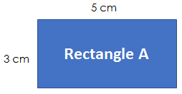

Rectangle B

Test the Conjecture 1) Circle B is created by applying a scale factor of ½ to Circle A. Determine the approximate area of Circle B using 3.14 for pi.

Circle A Circle B
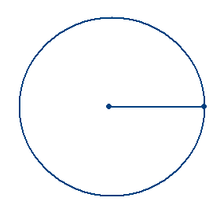

16mm

CFS for top quality work
  - Scale factor is annotated
  - Scale drawing is labeled with scaled side lengths
  - Work for area is shown with given formula

Test the Conjecture 2) The two triangles below are scaled figures. Determine the area of the larger triangle.
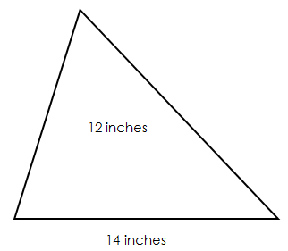
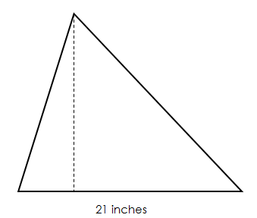

CFS for top quality work
  - Scale factor is annotated
  - Scale drawing is labeled with scaled side lengths
  - Work for area is shown with given formula

Conjecture
Scale factors do not apply to ___________

PARTNER PRACTICE

Bachelor Level

- The smaller square below is used to create the larger square by using a scale factor of 4. Determine the area of the larger square.
CFS for top quality work
  - Scale factor is annotated
  - Scale drawing is labeled with scaled side lengths
  - Work for area is shown with given formula

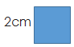

- Rectangle A is a ½ scale drawing of rectangle B. What is the area of rectangle A?
CFS for top quality work
  - Scale factor is annotated
  - Scale drawing is labeled with scaled side lengths
  - Work for area is shown with given formula

Rectangle A Rectangle B
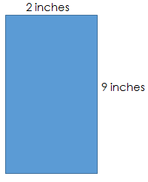

Master Level

- Determine the area of the smaller rectangle if the larger rectangle is a scale drawing of the smaller one.

1mm

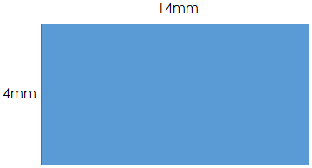

INDEPENDENT PRACTICE

CFS for top quality work
  - Scale factor is annotated
  - Scale drawing is labeled with scaled side lengths
  - Work for area is shown with given formula

Bachelor Level

- The area of a parallelogram can be found by multiplying the base times the height (a = bh). Use the diagram below to determine the area of the smaller parallelogram if a scale factor of $\frac{1}{3}$ is applied to the larger one to create it.
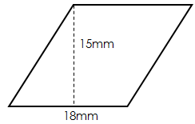

- Mark claims that he can multiply that area of Rectangle A by 4 to get the correct area of Rectangle B. Do you agree with him? Explain and prove your answer.

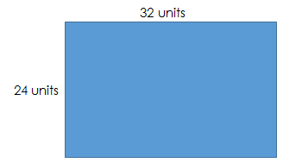
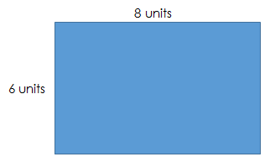

A
B

____________________________________________________________________________________________________________________________________________________________________________________________________________________________________________________________________________________________________________________________________________________________________________
Master Level

- A scale drawing of a circular pool measures 4 inches from one side to the other through the center. The scale of the drawing is 1inch = 5.5 feet. Read each statement below and determine whether you think the statement is “True” or “False.”

Statement | True | False
The diameter of the pool is 8 inches
The radius of the pool is 2 inches
To cover the pool, you would need a cover with an approximate area of 69.08 square feet
To cover the pool, you would need a cover with an approximate area of 379.94 square feet
The distance around the pool is approximately 69.08 feet

- The area of a trapezoid is a = ½ h(b₁ + b₂) where h is the height and b₁ and b₂ are the bases. Determine the area of the larger trapezoid if the two trapezoids are scaled figures.
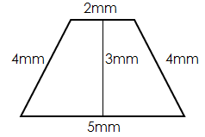
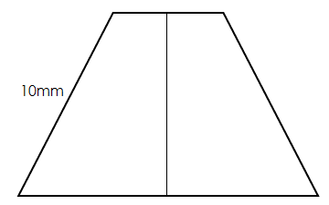

- Savannah used the scaled figures below to get an area of 135m² for the smaller triangle. Determine the correct area to determine what mistake did Savannah made while solving.
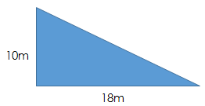

13.5m

____________________________________________________________________________________________________________________________________________________________________________________________________________________________________________________________________________________________________________________________________________________________________________

PhD Level

- Determine if a scale factor can be used to solve for the perimeter of a scaled figure using the rectangles below and applying a scale factor of 3 to the smaller rectangle.

7cm

3cm

- Explain why you think you got the answer you did and use it to explain why scale factor cannot be directly applied to area.

____________________________________________________________________________________________________________________________________________________________________________________________________________________________________________________________________________________________________________________________________________________________________________________________________________________________________
Name: ______________________________

Date: _______________________
CFS for top quality work
  - Scale factor is annotated
  - Scale drawing is labeled with scaled side lengths
  - Work for area is shown with given formula

EXIT TICKET
Self-assessment | I mastered the learning objective today. | I am almost there. | Need more practice and feedback.
Teacher feedback | You mastered the learning objective today. | You are almost there. | You need more practice and feedback.

- Square A has a side length of 6 cm. Square B is the resulting image after a scale factor of 2 has been applied to Square A. Shania says that the area of Square B is 2 times the area of Square A. Determine the area of Square B. Do you agree with Shania? Explain why or why not. If you disagree, describe the correct relationship between the two areas.

____________________________________________________________________________________________________________________________________________________________________________________________________________________________________________________________________________________________________________________________________________________________________________________________________________________________________________________________________________________________________________________________________________________________________________________

