Name: ___________________________

**CFS for top quality work**

* + Problem is annotated with **original and scaled figure**
  + Percent equation is used to determine the scale factor
  + Scale factor is given **as a percent**
  + Statement is made about which figure is being scaled if one is not given

Date: ____________________________

UNIT 6 LESSON 15

**AIM**: SWBAT determine the scale factor as a percent

**THINK ABOUT IT!**

Figure 1 was used to create Figure 2 by applying a scale factor. Determine the scale factor as a percent going from figure 1 to figure 2 showing all work. Explain

30 cm

Figure 1

10 cm

12 cm

Figure 2

4 cm

________________________________________________________________________________________________________________________________________________________________________________________________________________________________________________________________________________________________________________________________________________________________________________________________________

Test the Conjecture #1) Use the figures below to determine the scale factor as a percent going from figure 1 to figure 2.

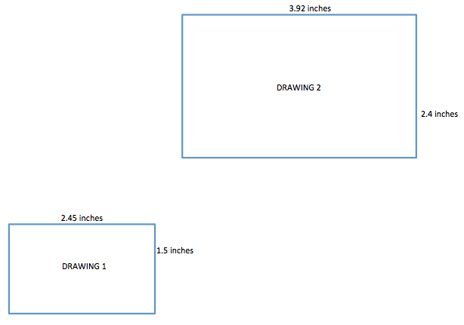

**CFS for top quality work**

* + Problem is annotated with **original and scaled figure**
  + Percent equation is used to determine the scale factor
  + Scale factor is given **as a percent**
  + Statement is made about which figure is being scaled if one is not given

Test the Conjecture #2) Use the same figures as the first problem to determine the scale factor as a percent going from figure 2 to figure 1.

**CFS for top quality work**

* + Problem is annotated with **original and scaled figure**
  + Percent equation is used to determine the scale factor
  + Scale factor is given **as a percent**
  + Statement is made about which figure is being scaled if one is not given

Conjecture

|  |
| --- |
| The scale factor as a __________ is a constant of proportionality |

**PARTNER PRACTICE**

**CFS for top quality work**

* + Problem is annotated with **original and scaled figure**
  + Percent equation is used to determine the scale factor
  + Scale factor is given **as a percent**
  + Statement is made about which figure is being scaled if one is not given

|  |
| --- |
| *Bachelor Level* |

1. Use the figures below to write two different scale factors that exist between the figures.

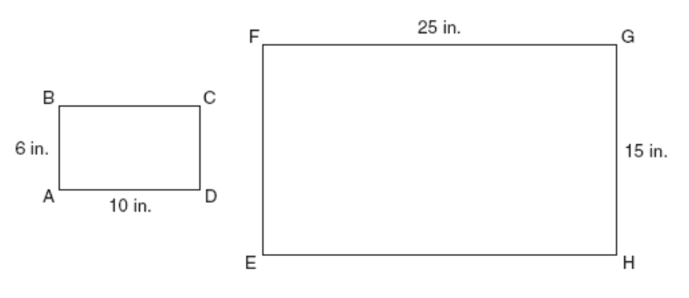

Figure 2

Figure 1

Figure 1 to Figure 2: ______________________

Figure 2 to Figure 1: ______________________

|  |
| --- |
| *Master Level* |

1. The larger figure was used to make a smaller scale drawing shown below.

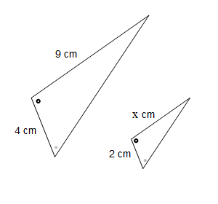

Step A: Determine the scale factor as a percent between the two figures.

Step B: Determine the missing side of the smaller figure using the scale factor you determined in Step A.

**INDEPENDENT PRACTICE**

**CFS for top quality work**

* + Problem is annotated with **original and scaled figure**
  + Percent equation is used to determine the scale factor
  + Scale factor is given **as a percent**
  + Statement is made about which figure is being scaled if one is not given

|  |
| --- |
| *Bachelor Level* |

* + - 1. Determine the scale factor that was applied to triangle NQR to create the scaled figure of N’Q’B’.

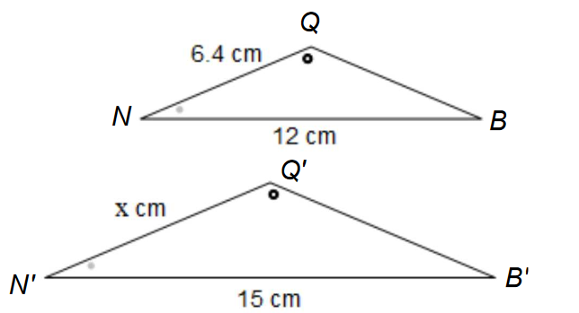

8 cm

* + - 1. Determine the scale factor going from the larger parallelogram to the smaller one.

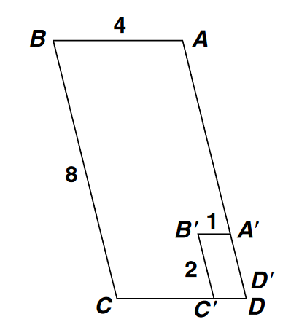

|  |
| --- |
| *Master Level* |

* + - 1. Determine two different scale factors that could be used to describe the relationship between the figures below:

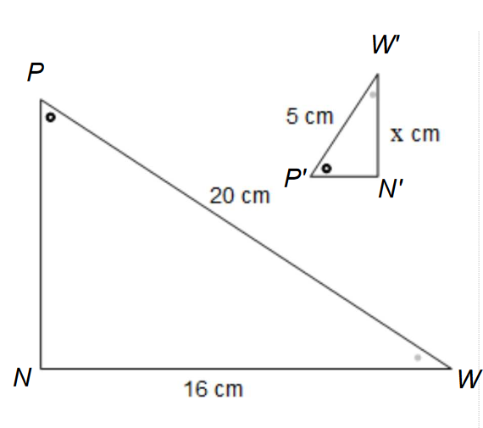

4cm

* + - 1. Josh claims that the scale factor to go from ABCD to the scaled figure A’B’C’D’ is 50%. Without doing any calculations, explain why that claim is false.

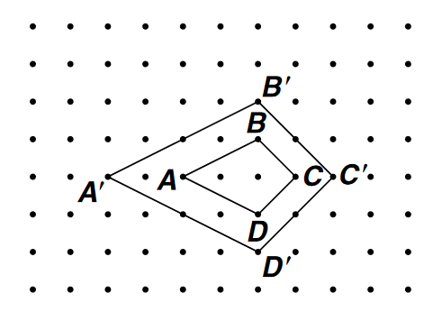

____________________________________________________________________________________________________________________________________________________________________________________________________________________________________________________________________________________________________________________________________________________________

* + - 1. Use the diagrams below to determine which statements are “true” and which are “false.”

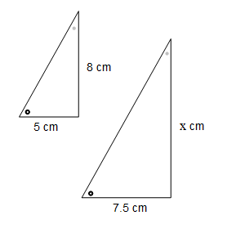

**B**

**A**

|  |  |  |
| --- | --- | --- |
| Statement | True | False |
| The scale factor to go from figure A to figure B must be less than 100% |  |  |
| The scale factor to go from figure B to figure A is 66 $\frac{2}{3}$% |  |  |
| To find the missing side length, you can multiply 8 by 66 $\frac{2}{3}$% |  |  |
| The missing side length is 12 cm |  |  |

|  |
| --- |
| *PhD Level* |

* + - 1. The scale factor from Drawing 1 to Drawing 2 is $112\%$, and the scale factor from Drawing 1 to Drawing 3 is $84\%$. Drawing 2 is also a scale drawing of Drawing 3. Is Drawing 2 a reduction or an enlargement of Drawing 3? Justify your answer using the scale factor. The drawing is not necessarily drawn to scale.

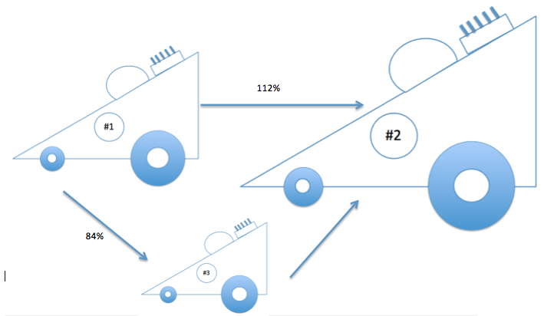

* + - 1. Explain how you could use the scale factors from Drawing 1 to Drawing 2 ($112\%$) and from Drawing 2 to Drawing 3 ($75\%$) to show that the scale factor from Drawing 1 to Drawing 3 is $84\%$.

______________________________________________________________________________________________________________________________________________________________________________________________________________________________________________________________________________________________________________________________________________________________________________________________________________________________________________________________________________________

**Name: ______________________________**

**CFS for top quality work**

* + Problem is annotated with **original and scaled figure**
  + Percent equation is used to determine the scale factor
  + Scale factor is given **as a percent**
  + Statement is made about which figure is being scaled if one is not given

**Date: _______________________**

**U6 L15 - EXIT TICKET**

|  |  |  |  |
| --- | --- | --- | --- |
| Self-assessment | I mastered the learning objective today. | I am almost there. | Need more practice and feedback. |
| Teacher feedback | You mastered the learning objective today. | You are almost there. | You need more practice and feedback. |

1. Use the drawings below to determine which 2 statements are correct. When necessary, round the answer to the nearest tenth of a percent. Show your work.



1. To go from Drawing 1 to Drawing 2, you apply a scale factor of 48%
2. To go from Drawing 1 to Drawing 2, you apply a scale factor of 210%
3. To go from Drawing 2 to Drawing 1, you apply a scale factor of 48%
4. To go from Drawing 2 to Drawing 1, you apply a scale factor of 210%