Name: ___________________________
CFS for top quality work
  - Equation and/or balance is written
  - Balance stays balanced by doing the same operation to each side.
  - Final answer is substituted in to check
Date: ____________________________
UNIT 4 LESSON 1

AIM: SWBAT solve two-step equations using a balance model

In my own words this means I will be able to…
__________________________________________________________________________________________________

__________________________________________________________________________________________________

THINK ABOUT IT!
Mark is working at a grocery store and is stacking apples. Before he stacks them, he puts them on a balance to weigh them. On the right side of the balance, he put 15 apples. On the other side of the balance, he puts two boxes of apples and three additional apples (pictured below). The weight on either side of the balance is equal, which keeps the balance balanced.

Step A: Write an equation to represent the balance.

Step B: If there is the same amount of apples in each box, how many apples are in each box

__________________________________________________________________________________________________________________________________________________________________________________________________________________________________________________________________________________________________________________________________________________________________________________________________________________________________________________________________________________________________________

Test the Conjecture #1) Write an equation that represent the model shown and solve for the variable.

CFS for top quality work
  - Equation and/or balance is written
  - Balance stays balanced by doing the same operation to each side.
  - Final answer is substituted in to check

Test the Conjecture #2) Model and solve the equation 3n + 15 = 36
CFS for top quality work
  - Equation and/or balance is written
  - Balance stays balanced by doing the same operation to each side.
  - Final answer is substituted in to check

Conjecture
Performing the same ________________ on each side of an equation keeps the equation _______________

PARTNER PRACTICE
CFS for top quality work
  - Equation and/or balance is written
  - Balance stays balanced by doing the same operation to each side.
  - Final answer is substituted in to check

Bachelor Level

- How many blocks would fit in each “x” box and still keep the scale balanced? Write an equation that could model the scale below.
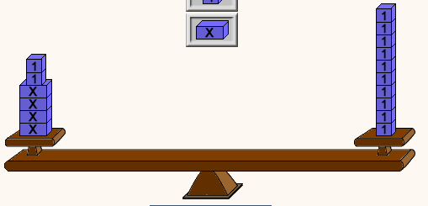

Master Level

- Model the equation 4x + 2 = 14 using a balance scale. Determine the value of x arithmetically using your model and prove that the value is correct.

- Model the equation 3n + 1 = 37 using a balance scale. Determine the value of x arithmetically using your model and prove that the value is correct.
INDEPENDENT PRACTICE
CFS for top quality work
  - Equation and/or balance is written
  - Balance stays balanced by doing the same operation to each side.
  - Final answer is substituted in to check

Bachelor Level

- Look at the scale below. Determine how many blocks are in each bag. Write an equation that models the scale.

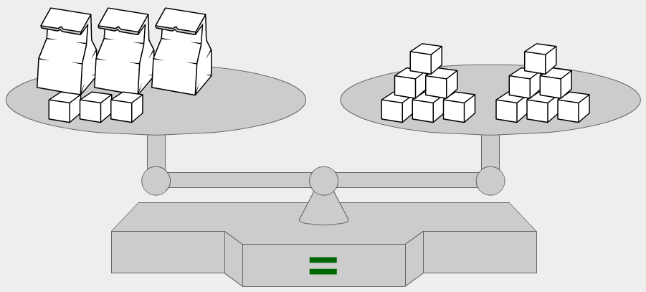

- How many units would be in each box according to the scale? What equation models the scale?

39

Master Level

- Model the equation 25+ 3d = 31 using a balance scale. Solve the equation arithmetically using your model and prove the answer is correct.

- Jamie thinks that there are 10 units in each box for the model below. Is Jamie correct? If so, how can you prove you answer without solving the problem? If not, what mistake did she make?

17

3

____________________________________________________________________________________________________________________________________________________________________________________________________________________________________________________________________________________________________________________________________________________________
- Model the equation 9n + 31 = 166 using a balance model and apply your model to solve for the variable arithmetically.

- At FedEx, Taryn is trying to ship three packages and a single weight that weighs three pounds. The total weight of her three packages and weight is 66 pounds. Draw a model and write an equation to represent this situation. Determine how much each package weighs.

PhD Level

- What is the value of each box in the model below? Explain how you determined and checked that your solution was correct.
21

-1

-1
-1

___________________________________________________________________________________________________________________________________________________________________________________________________________________________________________________________________________________________________________________________________________________________________________________________________________________________________________________

- Timmy is “n” years old and Tommy is 3 times Timmy’s age plus two years. If their combined age is 30, how old is Timmy? Draw any mondel aid you in solving and prove that your answer is correct.
Name: ______________________________
CFS for top quality work
  - Equation and/or balance is written
  - Balance stays balanced by doing the same operation to each side.
  - Final answer is substituted in to check

Date: _______________________

EXIT TICKET
Self-assessment | I mastered the learning objective today. | I am almost there. | Need more practice and feedback.
Teacher feedback | You mastered the learning objective today. | You are almost there. | You need more practice and feedback.

- Write an equation that represents the model below. Determine the value of one box and explain your steps.
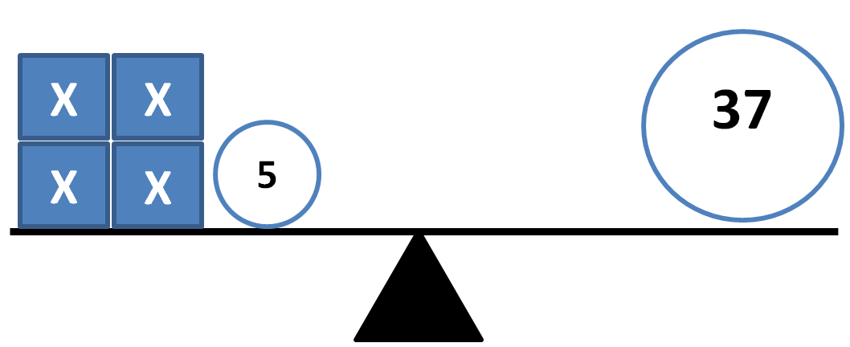

____________________________________________________________________________________________________________________________________________________________________________________________________________________________________________________________________________________________________________________________________________________________

- Use a balance model to represent and solve the equation 3x + 3 = 24. Explain your answer and how you kept the equation balanced.

