Name: ___________________________ Date: ____________________________
UNIT 8 LESSON 2

AIM: | SWBAT solve area problems with parallelograms

THINK ABOUT IT!
Louis’ teacher asked him to find the area of the parallelogram pictured below.
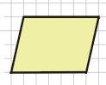
He wasn’t sure what the area formula was for parallelograms, so he cut a right triangle off of the left side of the parallelogram and moved the triangle to the other side of the parallelogram, forming a rectangle. You can see his steps below.
 | 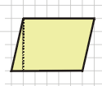 | 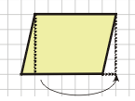 | 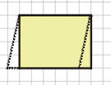  6 units  4 units
Assuming that what Louis did is okay, how should he find the area of the parallelogram? Show and explain in the space below.

__________________________________________________________________________________________

__________________________________________________________________________________________

__________________________________________________________________________________________

__________________________________________________________________________________________

__________________________________________________________________________________________

__________________________________________________________________________________________

Test the Conjecture
Test the Conjecture #1) What is the area of the parallelogram below?
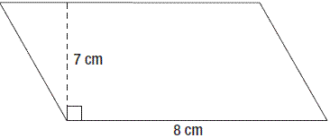
7.8 cm

Test the Conjecture #2) Tariq bought a rug in the shape of a parallelogram, shown below. How many square meters of space will the rug take up on his floor?
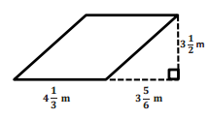

Conjecture
The area of a ___________________ is measured the same way as the _________ of a rectangle.

PARTNER PRACTICE
- CFS for top quality work
  - Problem is annotated
  - Model is drawn accurately and labeled
  - Formula is written
  - All calculations are shown /Answer statement is provided

Bachelor Level

- Find the area of each parallelogram below using two methods.

A
B

- Find the area of the parallelogram below:
5 cm
7.2 cm
9.6 cm

a) 36
b) 48
c) 69.12
d) 345.6
Master Level

- Do the rectangle and parallelogram below have the same area? Explain why or why not.
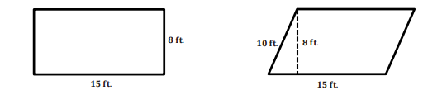

__________________________________________________________________________________________________

__________________________________________________________________________________________________

__________________________________________________________________________________________________

__________________________________________________________________________________________________

__________________________________________________________________________________________________

__________________________________________________________________________________________________

INDEPENDENT PRACTICE
- CFS for top quality work
  - Problem is annotated
  - Model is drawn accurately and labeled
  - Formula is written
  - All calculations are shown /Answer statement is provided

Bachelor Level

- Find the area of the parallelograms below using two methods

A
B

- Susan cut off a triangular piece of her parallelogram as shown below
Original shape Triangular piece cut out New Shape
Susan threw away the triangular piece and then claimed that the new shape has the same area as the original parallelogram. Do you agree with Susan? Explain why or why not.

__________________________________________________________________________________________________

__________________________________________________________________________________________________

__________________________________________________________________________________________________

__________________________________________________________________________________________________
Master Level

- What is the area of the parallelogram below?

2 ½ cm
1 ¾ cm
3 ¼ cm

- The parallelogram pictured below is a drawing of a miniature model that Mr. Cox made of this backyard.
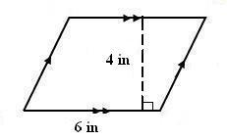
5 in
  - Mr. Sod is covering his yard with turf (a fake grass). He figures that the turf will cost about $7.50 per square inch. How much will he spend to cover his entire yard with turf?

  - He also wants to put a fence around his backyard. The fence will cost about $22 per inch. How much will he spend to put fence around the yard?

- Brittany and Sid were both asked to draw the height of a parallelogram. Their answers are below.
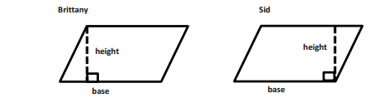

Who is correct? Explain your answer.
_______________________________________________________________________________________
_______________________________________________________________________________________
_______________________________________________________________________________________
_______________________________________________________________________________________
_______________________________________________________________________________________

Is there another way they could have drawn in the height? If so, draw the different way to identify the height on one of their parallelograms and explain.

_______________________________________________________________________________________
_______________________________________________________________________________________
_______________________________________________________________________________________
_______________________________________________________________________________________
_______________________________________________________________________________________

- The area of the parallelogram below is 24 cm² and its base is 4 cm. What is the parallelogram’s height?
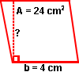
8cm

- A rectangle and a parallelogram have the same area. The rectangle, the parallelogram, and some of their dimensions are shown to the right. Based on the dimensions shown, what is the value of x?

PhD Level

- Amber is putting rug down on her floor. She drew a diagram of what the floor looks like. There are two types of rug that she likes. The first is blue and is on sale. It costs $8.50 per square foot and there is no installation fee. The second rug she likes is red and costs $5.50 per square foot. There is a $22.50 installation fee. If she wants to spend as little as possible on the rug, which rug should she buy? How much will she save if she buys the cheaper rug?
8 ft.
6.5 ft.
10 ft.

- CFS for top quality work
  - Problem is annotated
  - Model is drawn accurately and labeled
  - Formula is written
  - All calculations are shown /Answer statement is provided

Name: ______________________________ Date: _______________________
EXIT TICKET
Self-assessment | I mastered the learning objective today. | I am almost there. | Need more practice and feedback.
Teacher feedback | You mastered the learning objective today. | You are almost there. | You need more practice and feedback.

- Find the area of parallelogram A using the formula. Prove that the area is correct
A

- Jake wants to create an accent wall in his bedroom. He wants to put a patch of wall paper in the shape of the parallelogram shown below on one of his walls. How many square cm of wallpaper does he need? Show all work.
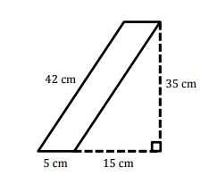

a) 175
b) 210
c) 630
d) 700

