CFS for top quality work
  - Expressions are written to represent situations in context
  - Sign of the product is labeled on the expression
  - All computation is shown
  - Final product is clearly labeled

Name: ___________________________
Date: ____________________________
UNIT 2 LESSON 3

AIM: SWBAT develop and apply the rules for multiplying two or more integers fluently

THINK ABOUT IT!
Fill in each box in the grid below by determining the product of the two numbers the box is in line with. For example, the -20 in the upper left corner is in line with the 5 and the -4. The product of 5 and -4 is -20. Three other examples have been provided for you.

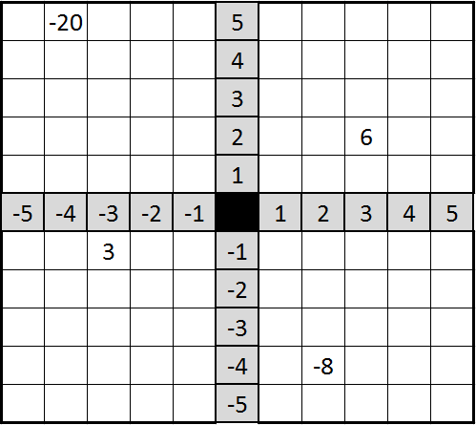

The 6 is in line with the 2 and the 3. 2 x 3 = 6

The -8 is in line with the 2 and the -4. 2 x (-4) = -8

The 3 is in line with the -3 and the -1. -3 x (-1) = 3

When you finish, what do you notice about the completed grid?

________________________________________________________________________________________________________________________________________________________________________________________________________________________________________________________________________________________________________________________________________________________________________________________________________
Test the Conjecture #1) Evaluate the two expressions:

-23 x 11 -14 x (-30)

CFS for top quality work
  - Expressions are written to represent situations in context
  - Sign of the product is labeled on the expression
  - All computation is shown
  - Final product is clearly labeled

Test the Conjecture #2) Will the product of the following expression be positive or negative?

-4 x 18 x (-112) x (-42)

CFS for top quality work
  - Expressions are written to represent situations in context
  - Sign of the product is labeled on the expression
  - All computation is shown
  - Final product is clearly labeled

Conjecture
The product of two numbers is positive if the signs are the ________ and negative if the signs are ___________

PARTNER PRACTICE

Bachelor Level

- Evaluate the following expressions:
  - 5 x (-9)
CFS for top quality work
  - Expressions are written to represent situations in context
  - Sign of the product is labeled on the expression
  - All computation is shown
  - Final product is clearly labeled

  - -8 x 7

  - -7 x (-4)

  - 11 x 10

  - -4 x (-5) x (-1)

- Will the product of -3 x (-4) x 7 be positive or negative? Explain your answer.

____________________________________________________________________________________________________________________________________________________________________________________________________________________________________________________________________________________________________________________________________________________________
Master Level

- What will the sign of the product be for the expression? Explain: -2.4 x –½ x 9 x -9.53 x -2 ¾

____________________________________________________________________________________________________________________________________________________________________________________________________________________________________________________________________________________________________________________________________________________________

- Evaluate the expression (-5) x (-3) x (-1) x (-2) x 4 x 1 x (-1)

INDEPENDENT PRACTICE

Bachelor Level

- Evaluate the following expressions:
CFS for top quality work
  - Expressions are written to represent situations in context
  - Sign of the product is labeled on the expression
  - All computation is shown
  - Final product is clearly labeled
  - -8 x 9

  - -12 x (-4)

  - 4(-11)

  - (-5)(-12)

- Will the expression -4 x (-6) x (-12) be positive or negative? Explain your reasoning.

____________________________________________________________________________________________________________________________________________________________________________________________________________________________________________________________________________________________________________________________________________________________

- Evaluate the expression in question 2.

Master Level

- Predict the sign of the product for each problem below, explain how you determined the correct sign and find the product.

- -4 x (-5) x (-8) x (-9)

____________________________________________________________________________________
____________________________________________________________________________________
____________________________________________________________________________________

Product: _______________

- 4 x (-15) x 9 x (-5) x 5

____________________________________________________________________________________
____________________________________________________________________________________
____________________________________________________________________________________

Product: ________________

- Circle all the expressions that will result in a product of -24
  - -1 x (-24) x (-1)
  - 6 x (-2) x 2 x (-2)
  - -6 x (-2) x 2 x (-2)
  - -3 x 4 x (-2)
  - -1(4)(-2)(3)
  - -2(-2)(-2)(-3)(-1)(-1)

- For all the expressions in number 6 that did not have a product of -24, rewrite the expression so that the product is -24.

- The product of two numbers is -100. One of the factors is less than 10 and more than 0. What are two possibilities of the factors? Explain your answer

____________________________________________________________________________________________________________________________________________________________________________________________________________________________________________________________________________________________________________________________________________________________

- Jonathan says that the expression -5 x (-3) x (-7) has a positive product because the signs of the factors are all the same. Do you agree with him? If so, evaluate the expression. If not, explain why he is incorrect.

____________________________________________________________________________________________________________________________________________________________________________________________________________________________________________________________________________________________________________________________________________________________
PhD Level

- Complete the statements with one of the options provided. Be prepared to justify your response.

If a > 0 and b < 0, ab will ______________ be positive.
- always b) sometimes c) never d) need more info

If a > 0 and b > 0, ab will ______________ be positive.
- always b) sometimes c) never d) need more info

If a < 0 and b < 0, ab will ___________________ be positive.
- always b) sometimes c) never d) need more info

If a > 0 and b < 0, the sum of a and b will _______________ be positive.
- always b) sometimes c) never d) need more info

If a > 0 and b < 0, the product abab will be __________________.
- positive b) negative c) 0 d) need more info

- Explain your reasoning for the last expression of the previous question.

____________________________________________________________________________________________________________________________________________________________________________________________________________________________________________________________________________________________________________________________________________________________

- Determine a generalized rule that will determine the sign of a multipliation expression with a certain number of negative integers.

____________________________________________________________________________________________________________________________________________________________________________________________________________________________________________________________________________________________________________________________________________________________

Name: ______________________________ Date: _______________________
EXIT TICKET
Self-assessment | I mastered the learning objective today. | I am almost there. | Need more practice and feedback.
Teacher feedback | You mastered the learning objective today. | You are almost there. | You need more practice and feedback.

- Simplify each expression below.
CFS for top quality work
  - Expressions are written to represent situations in context
  - Sign of the product is labeled on the expression
  - All computation is shown
  - Final product is clearly labeled
  - $34×\left(-8\right)$

  - $-12×\left(-19\right)$

- What will the sign of the product of the expression below be? Justify your answer.
(-5) x 22 x 18 x (-4) x (-27) x (-41)

a) positive
b) negative
c) no sign – the answer is 0
d) unable to determine – need more info

__________________________________________________________________________________________________________________________________________________________________________________________________________________________________________________________________________________________
______________________________________________________________________________________________

