Name: ___________________________ Date: ____________________________
UNIT 4 LESSON 4

AIM: | SWBAT solve problems using tape diagrams

THINK ABOUT IT!
Carly and Asia recently ran against each other for class president. The ratio of votes for Carly to votes for Asia was 4:1. There were 150 votes cast in the election. How many votes did Carly win the election by?

Key Point
Tape diagrams can be used to model and solve ratio problems involving a ________________.

Interaction with New Material

Ex. 1) The Aspen Ski Resort has started to keep track of the number of skiers and snowboarders who bought season passes. The ratio of the number of skiers who bought season passes to the number of snowboarders who bought season passes is 3:5. If 1,250 more snowboarders bought season passes than skiers, how many snowboarders and how many skiers bought season passes?

PARTNER PRACTICE
- CFS for top quality work
  - Problem is annotated with margin notes to provide additional meaning
  - Tape diagram is drawn accurately and is clearly labeled
  - Calculations are shown
  - Answer statement is written

Bachelor Level
- Ms. Chibbaro packs 6 almonds for every 3 craisins (cranberry raisins) in her snack pack. She has 12 more almonds than craisins. How many almonds does she have? How many craisins does she have?

- In Mariella’s class, there are 2 boys for every 3 girls. Today 5 new boys were added making the number of boys and girls the same. How many boys and girls were there originally?

Master Level

- The Hawaiian Pizza from Dominoes has a special ratio of 7 pineapple pieces for every 3 pieces of ham. Today they had extra ham, so they added 132 pieces of ham in total to their stock, making the amount of ham and pineapple equal. How many total pieces of pineapple and ham were in their stock originally?

INDEPENDENT PRACTICE
- CFS for top quality work
  - Problem is annotated with margin notes to provide additional meaning
  - Tape diagram is drawn accurately and is clearly labeled
  - Calculations are shown
  - Answer statement is written

Bachelor Level
- Dwhite can complete 5 laps around the track for every 2 laps that Jaden completes. Dwhite had an extra energy bar and competed 9 more laps than Jaden today. How many laps did Dwhite run? How many laps did Jaden run?

- In Ms. Regan’s closet, there is one gray t-shirt for every two black t-shirts. She buys 6 gray shirts so she now has an equal number of gray and black shirts. How many gray t-shirts and black t-shirts does she own now?

Master Level

- Review the student work below and determine whether or not it is correct. If it is correct, explain why. If it is incorrect, explain why and find the correct answer.

For every 2 earrings sold at a store, 6 bracelets are sold. Today they had an earring sale and sold 12 extra earrings, making the total number of earrings and bracelets sold the same. How many bracelets did they sell in total?

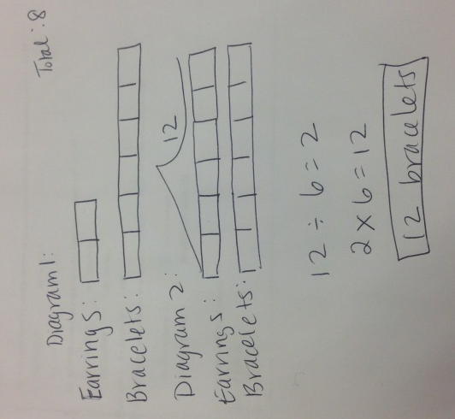

____________________________________________________________________________________

____________________________________________________________________________________

___________________________________________________________________________________________

- At a country concert, the ratio of the number of boys to the number of girls is 2:7. If there are 250 more girls than boys, how many boys are at the concert?

- Two brothers, Joe and Keith, saved $45 total in one week. Joe saved $15.

  - What is the ratio of the amount Joe saved to the amount Keith saved? Represent the ratio in simplest form.

  - The next week, the brothers saved $180. How much did each brother save?

  - Two sisters, Jen and Luz, also saved money together. Luz saved her money in the same ratio to the total as Keith did. She was able to save $70 on her own. How much the sisters saved altogether?

PhD Level

- Luis and Olivia are saving money to buy their favorite candy at the store. For every $5 Luis saves, Olivia saves $7. After a week, Luis saved $42 less than Olivia. If their favorite candy costs $2.50 per pack, how many packs of candy can each of them buy?

- A cashier sells 7 DVDs for every 3CDs she sells. On Monday she sold n more DVDs than CDs. Write an expression or expressions that you would use to solve this problem for the total number of each that she sells on Monday?.
- CFS for top quality work
  - Problem is annotated with margin notes to provide additional meaning
  - Tape diagram is drawn accurately and is clearly labeled
  - Calculations are shown
  - Answer statement is written

Name: ______________________________ Date: _______________________
EXIT TICKET
Self-assessment | I mastered the learning objective today. | I am almost there. | Need more practice and feedback.
Teacher feedback | You mastered the learning objective today. | You are almost there. | You need more practice and feedback.
- For every six hot dogs that are shipped to a store, two hamburgers are shipped. Yesterday, 12 hamburgers were added making the amount of hot dogs and hamburgers shipped equal. How many hot dogs and hamburgers were shipped originally?

- Josh was solving the following problem: The Superintendent of Highways is interested in the numbers of commercial vehicles that frequently use the county’s highways. He obtains information from the Department of Motor Vehicles for the month of September and finds that for every 14 non-commercial vehicles, there were 5 commercial vehicles. If there were 108 more noncommercial vehicles than commercial vehicles, how many of each type of vehicle frequently use the county’s highways during the month of September?

He says that he cannot solve it because 108/14 = a number with a decimal remainder.

What is the mistake that Josh is making? Find the mistake, and solve correctly.

____________________________________________________________________________________

____________________________________________________________________________________

____________________________________________________________________________________

____________________________________________________________________________________

