Name: ___________________________ Date: ____________________________

UNIT 8 LESSON 5

|  |  |
| --- | --- |
| AIM: | SWBAT solve area problems with obtuse triangles |

**THINK ABOUT IT!**

The triangle below is an obtuse triangle. Given what you have learned about measuring the area of triangles over the last two lessons, come up with two strategies for measuring the area of the triangle below.

4units

8 units

8 units

8.9 units

8.9 units

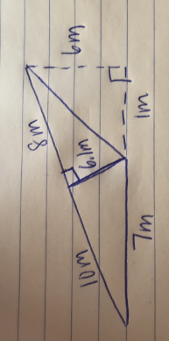**Test the Conjecture**

*Test the Conjecture #1)* What is the area of the triangle below?

* **CFS for top quality work**
  + Problem is annotated
  + Model is drawn accurately and labeled
  + Formula is written
  + All calculations are shown /Answer statement is provided

Conjecture

|  |
| --- |
| The area formula of a right triangle applies to __________ triangles |

**PARTNER PRACTICE**

|  |
| --- |
| *Bachelor Level* |

1. Find the area of each figure below.



* **CFS for top quality work**
  + Problem is annotated
  + Model is drawn accurately and labeled
  + Formula is written
  + All calculations are shown /Answer statement is provided



* **CFS for top quality work**
  + Problem is annotated
  + Model is drawn accurately and labeled
  + Formula is written
  + All calculations are shown /Answer statement is provided

|  |
| --- |
| *Master Level* |

1. What is the area of the triangle below?



**INDEPENDENT PRACTICE**

|  |
| --- |
| *Bachelor Level* |

1. Find the area of the triangle below in TWO ways.

3 mm

*4.5 mm 4.5 mm*

5.4 mm

5.4 mm

* **CFS for top quality work**
  + Problem is annotated
  + Model is drawn accurately and labeled
  + Formula is written
  + All calculations are shown /Answer statement is provided

2. Ke’Shaun is trying to find the area of the triangle below but thinks it is impossible because there is no height. Do you agree or disagree with his claim? Explain.



__________________________________________________________________________________________________

__________________________________________________________________________________________________

__________________________________________________________________________________________________

__________________________________________________________________________________________________

__________________________________________________________________________________________________

__________________________________________________________________________________________________

|  |
| --- |
| *Master Level* |

1. The Andersons were going on a long sailing trip during the summer. However, one of the sails on their sailboat ripped, and they have to replace it. The sail is pictured below.

If the sailboat sails are on sale for $2 a square foot, how much will the new sail cost?



1. Henry is creating a very small garden for inside his house. The garden is pictured below. He wants to cover the entire garden with grass. If grass is sold in containers of 1.5 square cm, how many containers will he need to cover the entire garden?

8.1cm

7.5 cm

3.2cm

|  |
| --- |
| *PhD Level* |

4. Which expressions can be used to find the area of the triangle below? Circle all that apply.



* 1. ½(97.7)(29.2) + ½(21.9)(29.2)
  2. ½(97.7)(29.2)
  3. ½(97.7)(29.2) – ½(21.9)(29.2)
  4. ½(97.7 – 21.9)(29.2)
  5. ½(75.8)(100.5)
  6. ½(75.8)(29.2)

5. Find the area of the figure below



**Name: ______________________________ Date: _______________________**

**EXIT TICKET**

|  |  |  |  |
| --- | --- | --- | --- |
| Self-assessment | I mastered the learning objective today. | I am almost there. | Need more practice and feedback. |
| Teacher feedback | You mastered the learning objective today. | You are almost there. | You need more practice and feedback. |

1. Find the area of the triangle below in two ways. Show all work.

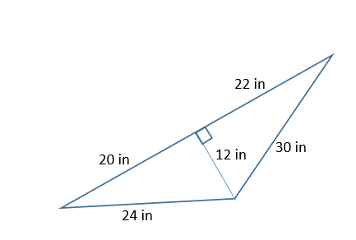

* **CFS for top quality work**
  + Problem is annotated
  + Model is drawn accurately and labeled
  + Formula is written
  + All calculations are shown /Answer statement is provided