Name: ___________________________ Date: ____________________________

UNIT 9 LESSON 6

|  |  |
| --- | --- |
| AIM: | SWBAT measure surface area |

**THINK ABOUT IT!**

What is the surface area, in square meters, of the figure below?

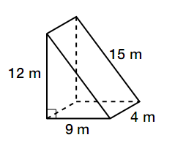

* **CFS for top quality work**
  + Problem is annotated
  + Model is labeled
  + All calculations are shown
  + Answer statement is written

Key Point

|  |
| --- |
| The surface area of a triangular prism is made up of _____________ and ______________ faces |

**Interaction with New Material**

*Ex. 1)* Ms. Fleck wants to build a tent that looks like the prism below. How many square feet of fabric will she need to create the tent?



* **CFS for top quality work**
  + Problem is annotated
  + Model is labeled
  + All calculations are shown
  + Answer statement is written

**PARTNER PRACTICE**

|  |
| --- |
| *Bachelor Level* |

* + - 1. What is the surface area of the net below?

**[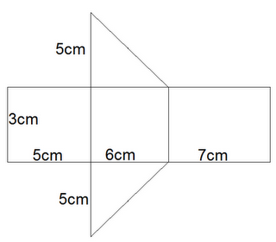](http://2.bp.blogspot.com/_VtC2aVcDkyI/S4iP4dPuitI/AAAAAAAAAGQ/9CEqrUYVQXA/s320/Triangular+Prism+Net2.png)**

* **CFS for top quality work**
  + Problem is annotated
  + Model is labeled
  + All calculations are shown
  + Answer statement is written

|  |
| --- |
| *Master Level* |

* + - 1. The door stopper below is shaped like a triangular prism. The janitorial staff wants to repaint the door stoppers. Find how many square inches covers the door stopper.



**INDEPENDENT PRACTICE**

|  |
| --- |
| *Bachelor Level* |

1. The net of a triangular prism is drawn below. What is the surface area of the prism?



* **CFS for top quality work**
  + Problem is annotated
  + Model is labeled
  + All calculations are shown
  + Answer statement is written

1. What is the surface area of the triangular prism below?

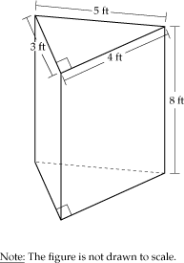

* **CFS for top quality work**
  + Problem is annotated
  + Model is labeled
  + All calculations are shown
  + Answer statement is written

|  |
| --- |
| *Master Level* |

1. Ms. Regan just bought a new coffee table and it is shaped like a triangular prism. An image of the table (flipped upside down) is shown below. She’s going to paint all of the surfaces of the coffee table except for the two triangular faces. How many square meters of paint does she need to buy?

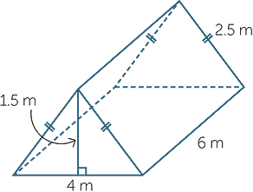

1. Write two different expressions that could be used to find the entire surface area of the coffee table above.

_______________________________________

_______________________________________

1. Gary has a small fish tank, shown below. Use the tank to answer the following questions.



* 1. If Gary fills the tank to the top, how many cubic cm of water will he put in the tank?
  2. Gary cleaned the entire outside of the fish tank. If he cleaned every surface, how many square centimeters did he clean?

|  |
| --- |
| *PhD Level* |

1. Justin works at a factory that produces Toberlone chocolate bars. The Toberlone bars are shaped like rectangular prisms. Each bar is wrapped with cardboard to cover every surface without any overlap. If Justin’s factory wraps 500 Toblerone bars each day and uses sheets of cardboard that are 200 square centimeters, how many sheets of cardboard does the factory use?

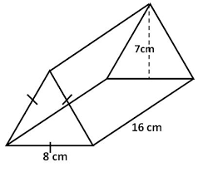

10.5 ft

**Name: ______________________________ Date: _______________________**

**EXIT TICKET**

|  |  |  |  |
| --- | --- | --- | --- |
| Self-assessment | I mastered the learning objective today. | I am almost there. | Need more practice and feedback. |
| Teacher feedback | You mastered the learning objective today. | You are almost there. | You need more practice and feedback. |

* **CFS for top quality work**
  + Problem is annotated
  + Model is labeled
  + All calculations are shown
  + Answer statement is written

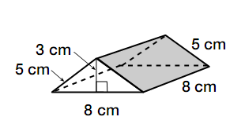

1. Above is a drawing of a camping tent. Draw a net to represent the tent. Label each dimension of the net.
2. How many square centimeters of fabric are needed to make the tent?