Name: ___________________________ Date: ____________________________

UNIT 10 LESSON 7

|  |  |
| --- | --- |
| AIM: | SWBAT interpret histograms |

**THINK ABOUT IT!**

The graph below shows the distribution of scores of 30 students on a mathematics test.

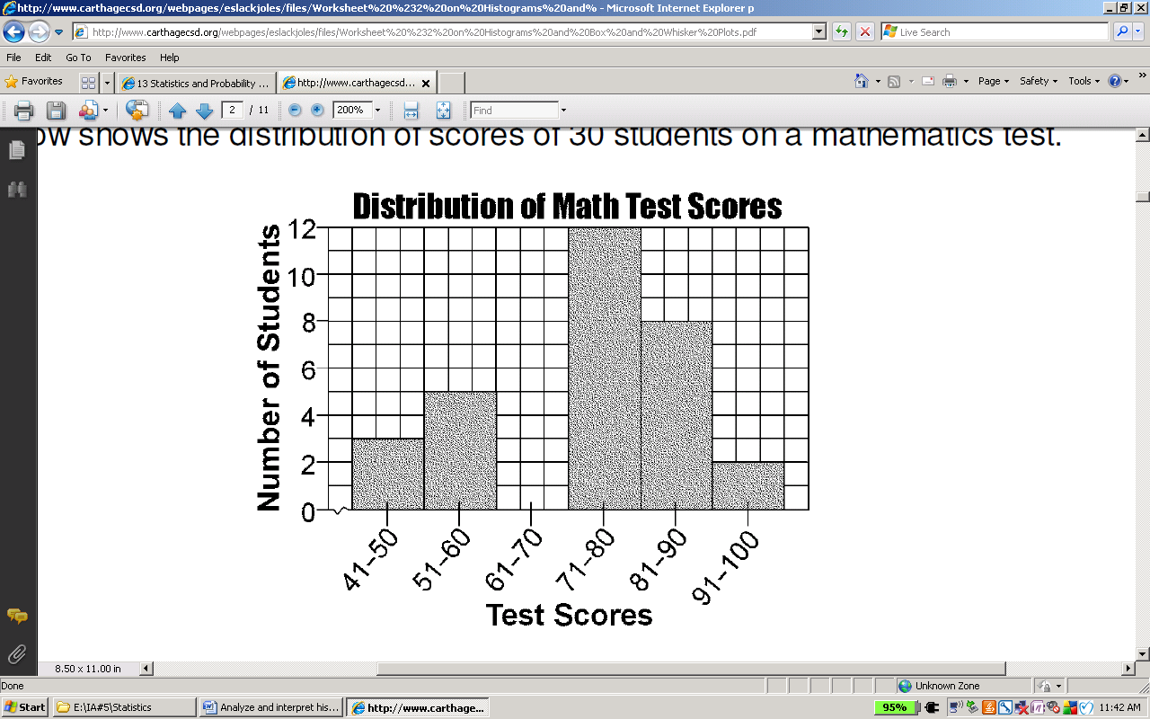

What does the first bar represent in the histogram?

_______________________________________________________________________________________

_______________________________________________________________________________________

_______________________________________________________________________________________

How many students scored higher than an 80?

What information does the x-axis provide? How are the data organized?

_______________________________________________________________________________________

_______________________________________________________________________________________

_______________________________________________________________________________________

_______________________________________________________________________________________

Key Point

|  |
| --- |
| A _____________________ is a graph that displays the frequency of __________ grouped into intervals |

**Interaction with New Material**

*Ex. 1)* Scientists collected data from many samples of yellow perch fish because they were concerned about the survival of the yellow perch fish. They captured yellow perch from a lake in this region, recorded data on each fish in a histogram, and then returned each fish to the lake. Consider the following histogram of data on the length (in centimeters) for a sample of yellow perch. Scientists were concerned about the survival of the yellow perch as they studied the histogram.

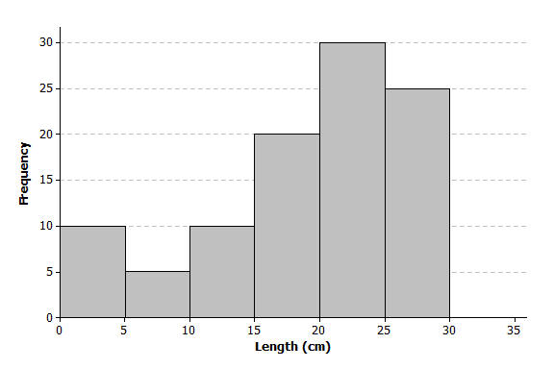

* + 1. Complete the frequency table using the histogram.

|  |  |
| --- | --- |
| **Length of fish in centimeters (cm)** | **Number of fish** |
| $0 - < 5$ cm |  |
| $5 - < 10$ cm |  |
| $10 - < 15$ cm |  |
| $15 - < 20$ cm |  |
| cm |  |
| cm |  |

* + 1. Describe the histogram in terms in terms of shape, center, and spread

Center (average/mean):

Spread (Minimum—maximum):

**Flip Over ->**

* + 1. Why might the scientists be concerned about the survival of the yellow perch?

_______________________________________________________________________________________

_______________________________________________________________________________________

_______________________________________________________________________________________

_______________________________________________________________________________________

_______________________________________________________________________________________

_______________________________________________________________________________________

**PARTNER PRACTICE[1]**

CFS:

* Annotations: circle key words/underline what you’re solving for
* Shape is described
* All work is shown for calculating measures of center and spread

|  |
| --- |
| *Bachelor Level* |

* + - 1. Another sample of Great Lake yellow perch from a different lake was collected. A histogram of the lengths for the fish in this sample is shown below:

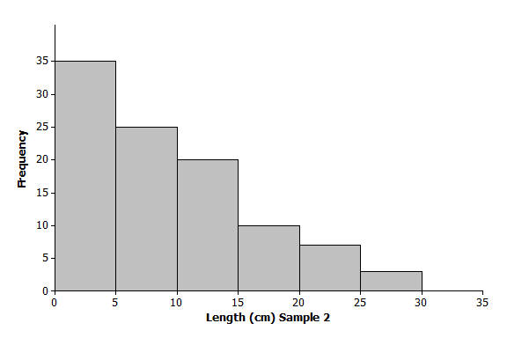

1. Complete the frequency table

|  |  |
| --- | --- |
| **Length (cm)** | **Number of fish** |
| 0-5 |  |
| 6-10 |  |
| 11-15 |  |
| 16-20 |  |
| 21-25 |  |
| 26-30 |  |

1. Describe the shape of the data distribution (is it skewed to one direction?).

_______________________________________________________________________________________

_______________________________________________________________________________________

_______________________________________________________________________________________

1. How would you describe the center of the data in this graph? What does it represent in the context of the graph?

_______________________________________________________________________________________

_______________________________________________________________________________________

_______________________________________________________________________________________

***Turn to next page!***

1. How would you describe the spread of the data in this graph? What does it represent in the context of the graph?

_______________________________________________________________________________________

_______________________________________________________________________________________

_______________________________________________________________________________________

_______________________________________________________________________________________

|  |
| --- |
| *Master Level* |

* + - 1. Should scientists be worried about the yellow perch in the second graph? Why? Support your answer with mathematical reasoning.

_______________________________________________________________________________________

_______________________________________________________________________________________

_______________________________________________________________________________________

_______________________________________________________________________________________

_______________________________________________________________________________________

_______________________________________________________________________________________

**INDEPENDENT PRACTICE[2]**

CFS:

* Problem is annotated with margin notes to provide additional meaning
* Shape is described
* All work is shown for calculating measures of center and spread

|  |
| --- |
| *Bachelor Level* |

The histogram below shows the number of books read during the school year by the students in Ms. Brown’s four language arts classes. Use the histogram to answer the following questions.



* + - 1. Based on the graph, which interval has the least frequency?
      2. How many students read between 20 and 59 books?
      3. How would you describe the shape of the histogram?

_______________________________________________________________________________________

_______________________________________________________________________________________

* + - 1. How would you describe the center?

_______________________________________________________________________________________

______________________________________________________________________________________________

* + - 1. How would you describe the spread?

_______________________________________________________________________________________

|  |
| --- |
| *Master Level* |

* + - 1. The histogram below shows the heights of the students in Kyra’s health class.

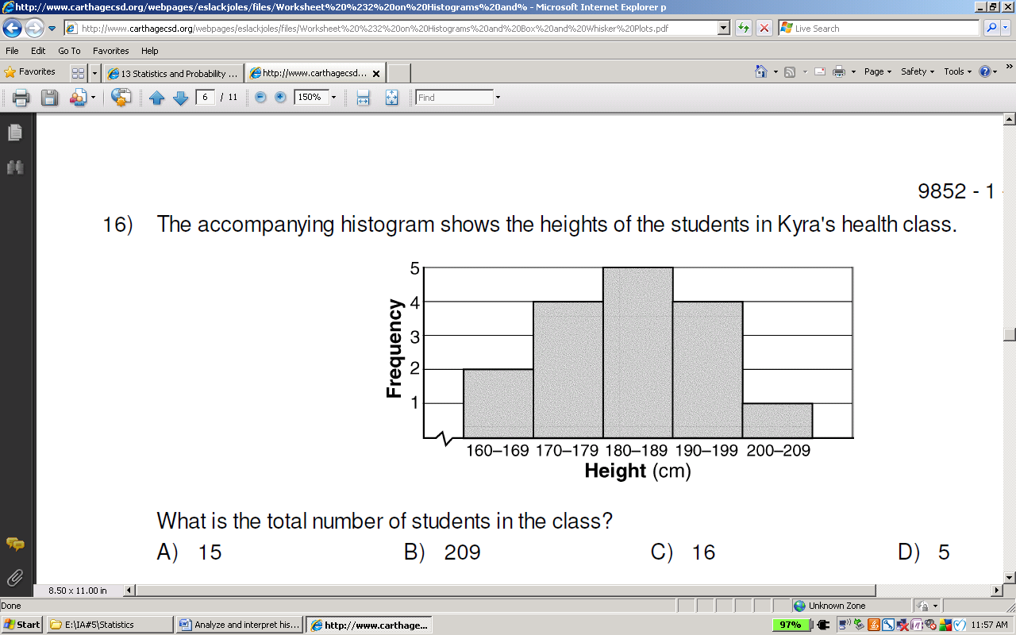

Complete the frequency table to represent the data in the histogram

|  |  |
| --- | --- |
| **Height (cm)** | **Number of students** |
|  |  |
|  |  |
|  |  |
|  |  |
|  |  |

Which of the following statements are true? Select all that apply.

* 1. The total number of students is 5
  2. 25% of the students are between 170 and 179 centimeters tall
  3. Over 75% of students fall between the height range of 170-199 cm
  4. The data are approximately symmetrical
  5. The center of the data is about 185 cm

*Use this space below to show your work for problem 6.*

* + - 1. The histogram shows the number of pairs of shows owned by sophomores at Amistad High School.

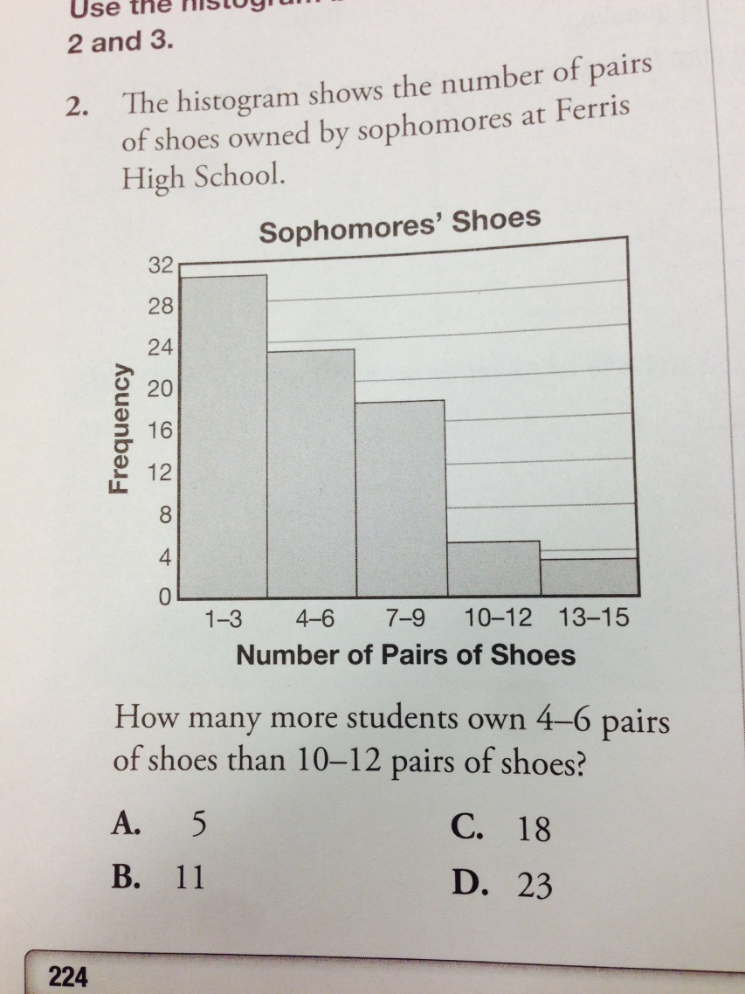[3]

Based on the shape, center, and spread of the graph, what conclusion(s) can you draw about the sophomores at Amistad High School?

_______________________________________________________________________________________

_______________________________________________________________________________________

_______________________________________________________________________________________

_______________________________________________________________________________________

_______________________________________________________________________________________

_______________________________________________________________________________________

Why does it make sense that a histogram was used to display the data collected above?

_______________________________________________________________________________________

_______________________________________________________________________________________

_______________________________________________________________________________________

_______________________________________________________________________________________

|  |
| --- |
| *PhD Level* |

* + - 1. Use the histogram below to answer the following question.8

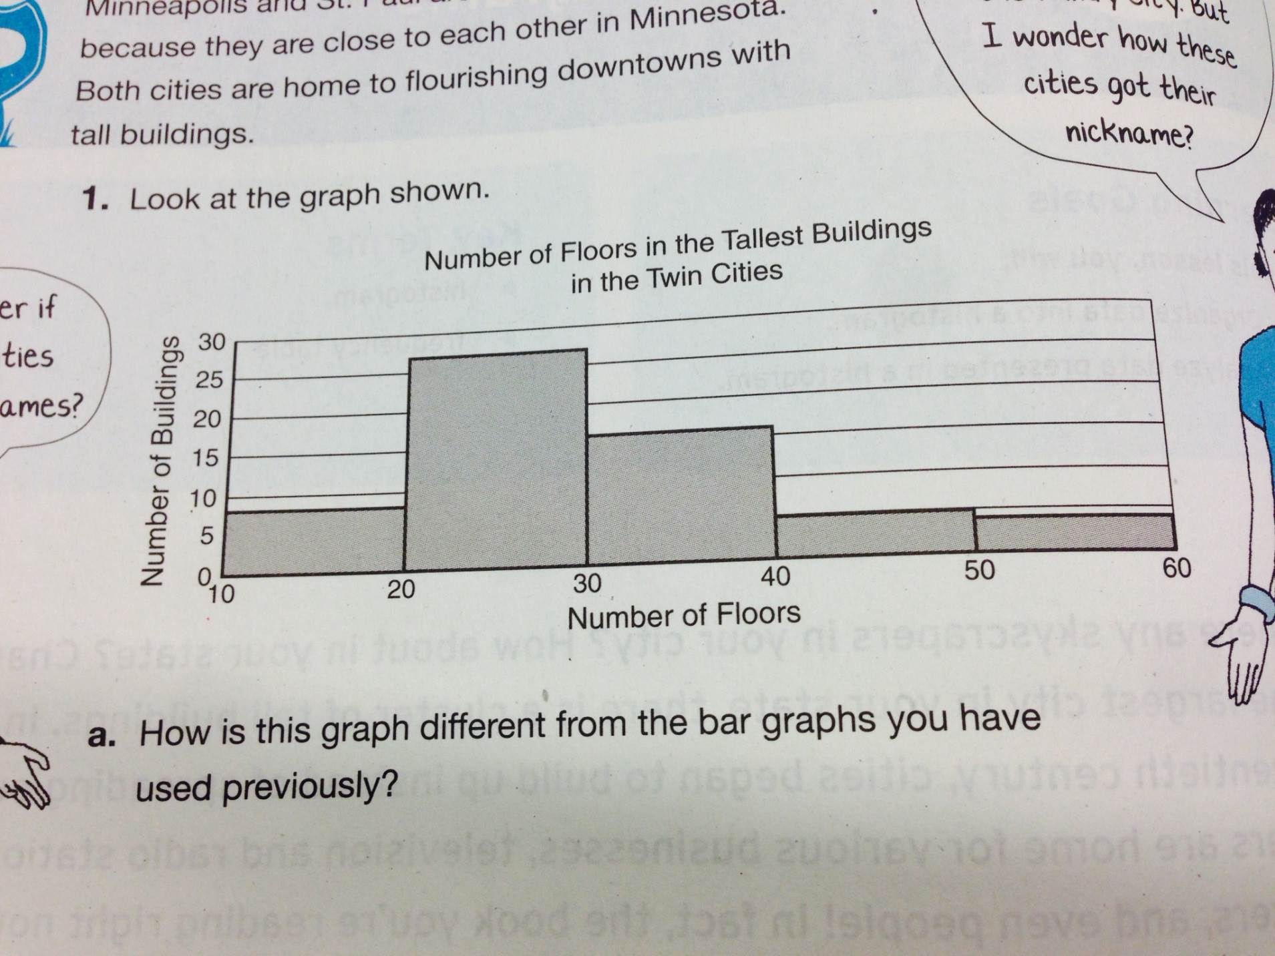

Imagine that you are an architect hired by a company to build a new building in the Twin Cities. The company wants you to design a building that is slightly bigger than the typical size of the tallest buildings in the Twin Cities without changing the overall shape of the skyline in the city. What would you recommend for a building design to the company? Why? Use mathematical reasoning.

_______________________________________________________________________________________

_______________________________________________________________________________________

_______________________________________________________________________________________

_______________________________________________________________________________________

_______________________________________________________________________________________

_______________________________________________________________________________________

_______________________________________________________________________________________

_______________________________________________________________________________________

**Name: ______________________________**

CFS:

* Problem is annotated with margin notes to provide additional meaning
* Shape is described
* All work is shown for calculating measures of center and spread

**Date: _______________________**

**U10L7 EXIT TICKET3**

|  |  |  |  |
| --- | --- | --- | --- |
| Self-assessment | I mastered the learning objective today. | I am almost there. | Need more practice and feedback. |
| Teacher feedback | You mastered the learning objective today. | You are almost there. | You need more practice and feedback. |

* + - 1. A biologist collected data to answer the question: “How many eggs do robins lay?” The following is a frequency table of the collected data.

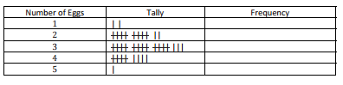

1. Complete the frequency column.
   * + 1. The histogram below shows the outside morning temperatures over 30 days. Use this histogram to answer the following questions.



* 1. Why was a histogram the best way to represent the data?

__________________________________________________________________________________________________

__________________________________________________________________________________________________

__________________________________________________________________________________________________

__________________________________________________________________________________________________

* 1. How many days was the morning temperature above 24 degrees?

***Flip over! Next page!***

* 1. What does the shape of the histogram tell you about outside morning temperatures?

__________________________________________________________________________________________________

__________________________________________________________________________________________________

__________________________________________________________________________________________________

__________________________________________________________________________________________________

__________________________________________________________________________________________________

1.
2.
3.