Name: ___________________________ Date: ____________________________

UNIT 9 LESSON 7

|  |  |
| --- | --- |
| AIM: | SWBAT measure surface area |

**THINK ABOUT IT!**

The two figures below are both pyramids. In each figure, all triangular faces are congruent. Without actually calculating the surface area, describe whether or not you can determine the surface area of both figures in the same way. Support your claim by drawing nets of each pyramid.

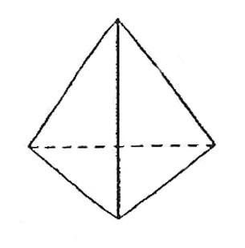

4cm

6cm

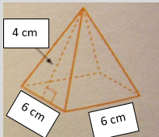

__________________________________________________________________________________________________

__________________________________________________________________________________________________

__________________________________________________________________________________________________

__________________________________________________________________________________________________

__________________________________________________________________________________________________

Key Point

|  |
| --- |
| The number of faces used to measure the surface area of a  pyramid depends on the base. |

**Interaction with New Material**

* **CFS for top quality work**
  + Problem is annotated
  + Model is drawn and labeled
  + All calculations are shown
  + Answer statement is written

*Ex. 1)* Find the surface area of the pyramid below.



*Ex. 2)* Find the surface area of the pyramid below.

* **CFS for top quality work**
  + Problem is annotated
  + Model is drawn and labeled
  + All calculations are shown
  + Answer statement is written



4cm

6cm

**PARTNER PRACTICE**

|  |
| --- |
| *Bachelor Level* |

* + - 1. What is the surface area of the net below?
* **CFS for top quality work**
  + Problem is annotated
  + Model is drawn and labeled
  + All calculations are shown
  + Answer statement is written

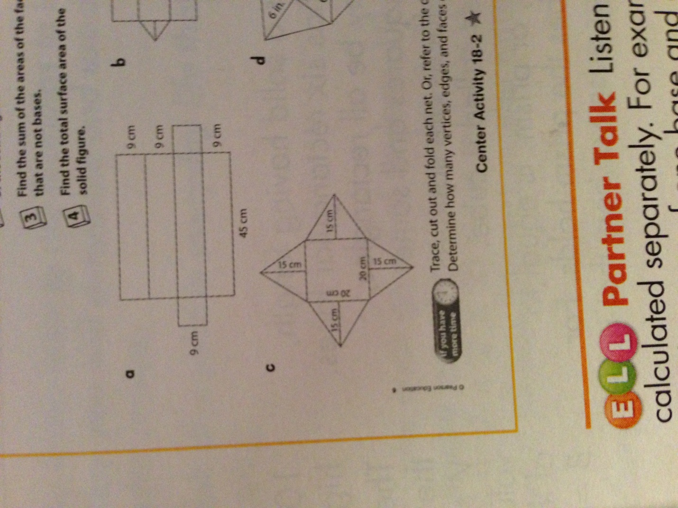

|  |
| --- |
| *Master Level* |

* + - 1. What is the surface area of the rectangular pyramid below?

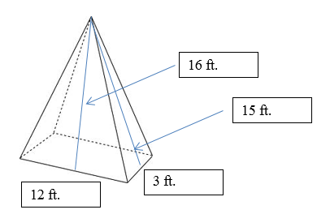

**INDEPENDENT PRACTICE**

|  |
| --- |
| *Bachelor Level* |

1. The figure below shows the net of a triangular pyramid. The given height is rounded to the nearest hundredth.



If all the triangles are equilateral, what is the surface area of the pyramid in square centimeters?

* **CFS for top quality work**
  + Problem is annotated
  + Model is drawn and labeled
  + All calculations are shown
  + Answer statement is written

1. 86.6
2. 43.3
3. 32.48
4. 10.83
5. What is the surface area of the pyramid below?

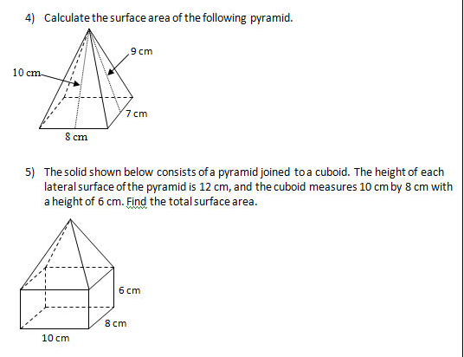

* **CFS for top quality work**
  + Problem is annotated
  + Model is drawn and labeled
  + All calculations are shown
  + Answer statement is written

|  |
| --- |
| *Master Level* |

1. A net of a square pyramid is shown below.

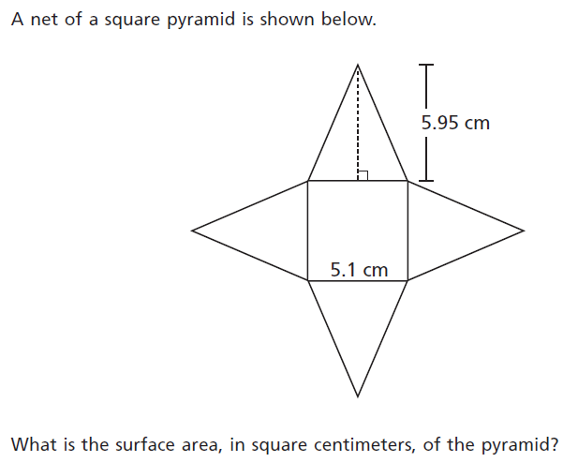

Part A: Which expressions below represent the surface area of the pyramid? Select all that apply.

a) 4 x 5.1 x 5.95

b) (5.1 x 5.1) + (5.1 x 5.95)

c) (5.1 x 5.1) + 4(5.1 x 5.95)

c) (5.1 x 5.1) + (5.1 x 5.95 x $\frac{1}{2}$) + (5.1 x 5.95 x $\frac{1}{2}$) + (5.1 x 5.95 x $\frac{1}{2}$) + (5.1 x 5.95 x )

d) 5.12 + 4(5.1 x 5.95 x $\frac{1}{2}$)

Part B: What is the surface area of the pyramid?

1. Latoya is repainting her toy pyramid (pictured below). All triangular faces of the pyramid are congruent. She is buying paint in containers that each hold enough paint to cover 100 square inches of space. How many containers does she need to buy?



16 in

24 in

5) The figure below is a model of a pyramid. Mr. Kaiser wants to repaint the sides of the pyramid but not the base. If each container of paint holds one gallon of paint that can paint 50 sq. centimeters. How many containers of paint will he need to buy?

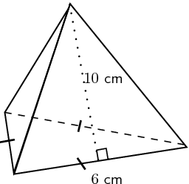

|  |
| --- |
| *PhD Level* |

1. Christina is painting a toy pyramid of hers orange. The pyramid is a square pyramid where the length of each side of the base is 10 meters and the slant height is also 10 meters. The orange paint she wants to buy is sold in buckets with enough paint to each over 25 square meters of space. Each bucket cost $9.99. How much money will she have to spend on painting her toy pyramid?
2. Mr. Fixit built a building in the shape of a square pyramid. He wanted to paint every other side red and the other two sides blue. The pyramid has a height of 8 feet and the base is 12 feet long. The red paint only covers 32 square feet per gallon, and the blue paint covers 46 square feet per gallon. How many gallons of each color will he need to paint the sides of the pyramid?

10.5 ft

* **CFS for top quality work**
  + Problem is annotated
  + Model is drawn and labeled
  + All calculations are shown
  + Answer statement is written

**Name: ______________________________ Date: _______________________**

**EXIT TICKET**

|  |  |  |  |
| --- | --- | --- | --- |
| Self-assessment | I mastered the learning objective today. | I am almost there. | Need more practice and feedback. |
| Teacher feedback | You mastered the learning objective today. | You are almost there. | You need more practice and feedback. |

1. 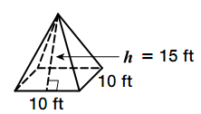Jim wants to paint his daughter’s dollhouse, which is pictured below. He only has enough paint to paint 200 square feet.

Part A: Which expression could he use to find out how many square feet he would need to paint to cover the doll-house?

a) 10 x 10 x 15

b) (10 x 10) + (15 x 10)

c) (10 x 10) + (15 x 10 x $\frac{1}{2}$)

d) (10 x 10) + 4(15 x 10 x $\frac{1}{2}$)

Part B: Does he have enough paint to cover the figure?