Name: ___________________________ Date: ____________________________
UNIT 10 LESSON 8

AIM: | SWBAT create histograms

THINK ABOUT IT!
On the calendar below, Mindy recorded the daily high temperature in degrees Fahrenheit (°F) for the first fifteen days in May. Mindy wants to know the shape of the distribution of the temperatures.
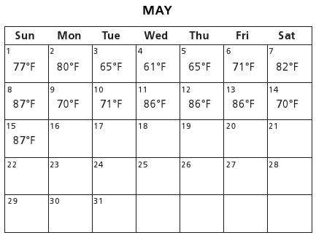
              - Create a frequency table and a histogram to model the data.

86-90
81-85
76-80
66-70
71-75
Daily High Temperatures May 1-15
Number of Days
Temperature (°F)
0
0
1
2
3
4
5
61-65

              - Which representation will best help Mindy know the shape of the data- the frequency table or the histogram? Why?

_______________________________________________________________________________________

_______________________________________________________________________________________

_______________________________________________________________________________________

_______________________________________________________________________________________

Key Point
A ___________________ allows one to easily see the ___________ of a data set’s distribution.

Interaction with New Material³
Ex. 1) Mr. Tillman graded his students’ interim assessments and wants to share the data with his class. The students’ scores are as follows:

63, 65, 73, 72, 86, 77, 89, 75, 62, 63, 92, 75, 88, 95, 89, 81, 99, 82, 79, 88, 92

        - Create a frequency table and histogram to model the data.

        - What conclusions can you draw based on the shape, center, and spread of the data?

_______________________________________________________________________________________

_______________________________________________________________________________________

_______________________________________________________________________________________

_______________________________________________________________________________________

_______________________________________________________________________________________

_______________________________________________________________________________________
PARTNER PRACTICE
CFS:
  - Frequency Tables
    - Column Headings with units (Intervals, tally, frequency)
    - Appropriate intervals
  - Histograms include
    - Title
    - Labels with units
    - Appropriate interval
    - Bars that are touching and of equal width

Bachelor Level

      - The scores on a mathematics test were:

70, 55, 61, 80, 85, 72, 65, 40, 74, 68

Complete the accompanying frequency table and use the table to construct a histogram for these scores.

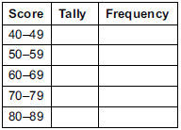

Master Level

Use problem 1 to answer the following questions:

      - Describe the shape, center, and spread of the data

_______________________________________________________________________________________

_______________________________________________________________________________________

_______________________________________________________________________________________

_______________________________________________________________________________________

_______________________________________________________________________________________

_______________________________________________________________________________________

      - What percent of the students failed the test (<70%)?

      - In which interval would you most likely find the median? Explain.

_______________________________________________________________________________________

_______________________________________________________________________________________

_______________________________________________________________________________________

_______________________________________________________________________________________

_______________________________________________________________________________________

INDEPENDENT PRACTICE
CFS:
  - Frequency Tables
    - Column Headings with units (Intervals, tally, frequency)
    - Appropriate intervals
  - Histograms include
    - Title
    - Labels with units
    - Appropriate interval
    - Bars that are touching and of equal width

Bachelor Level

            - The boys and girls basketball teams at Roosevelt Middle School wanted to raise money to help buy new uniforms. They decided to sell hats with the school logo on the front to family members and other interested fans. To obtain the correct hat size, the students had to measure the head circumference (distance around the head) of the adults who wanted to order a hat. The following data represents the head circumferences, in millimeters (mm), of the adults:

513, 525, 531, 533, 535, 535, 542, 543, 546, 549, 551, 552, 552, 553, 554, 555, 560, 561, 563, 563, 563, 565, 565, 568, 568, 571, 571, 574, 577, 580, 583, 583, 584, 585, 591, 595, 598, 603, 612, 618

The hats come in six sizes: XS, S, M, L, XL, and XXL. Each hat size covers a span of head circumferences. The hat manufacturer gave the students the table below that shows the interval of head circumferences for each hat size.

- Complete the frequency table below

Hat Sizes | Interval of Head Circumference (mm) | Tally | Frequency
XS
S
M
L
XL
XXL

- Create a histogram of the data

Master Level

      - Ms. Patel wants to know where she can buy a big bag of Flamin’ Hot Cheetos for the cheapest cost. She has researched 12 stores and found the following prices:

$0.50 $1.25 $0.99 $0.59
$0.75 $1.07 $1.09 $0.89
$0.49 $0.66 $1.01 $0.77

Create a frequency table and histogram using the data above.

- What is a typical price for the Cheetos? How do you know? Support your answer with mathematical reasoning.

_______________________________________________________________________________________

_______________________________________________________________________________________

_______________________________________________________________________________________

- What percent of the chips cost under 60%?

- What does the shape of the data tell you about the cost of Cheetos?

_______________________________________________________________________________________

_______________________________________________________________________________________

_______________________________________________________________________________________
PhD Level

      - Data Set 3 consists of data on the number of text messages sent in one month for 100 teenage girls who have a cell phone. Data Set 4 consists of data on the number of text messages sent in one month for 100 teenage boys who have a cell phone. Histograms of the two data sets are shown below.
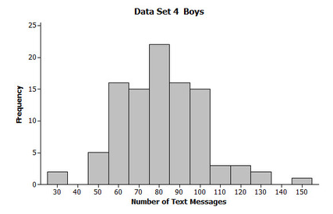
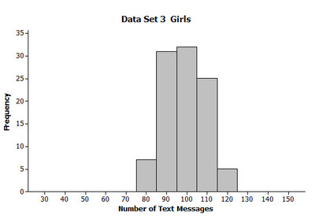

        - Describe the data distribution of number of text messages for the girls. Be sure to comment on center, spread and overall shape.

_______________________________________________________________________________________

_______________________________________________________________________________________

_______________________________________________________________________________________

        - On average, did the girls (Data Set 3) or the boys (Data Set 4) send more text messages? How do you know?

_______________________________________________________________________________________

_______________________________________________________________________________________

_______________________________________________________________________________________

        - Which of Data Set 3 and Data Set 4 has greater spread? By how much?

_______________________________________________________________________________________

_______________________________________________________________________________________

_______________________________________________________________________________________

Name: ______________________________
CFS:
  - Frequency Tables
    - Column Headings with units (Intervals, tally, frequency)
    - Appropriate intervals
  - Histograms include
    - Title
    - Labels with units
    - Appropriate interval
    - Bars that are touching and of equal width

Date: _______________________
EXIT TICKET
Self-assessment | I mastered the learning objective today. | I am almost there. | Need more practice and feedback.
Teacher feedback | You mastered the learning objective today. | You are almost there. | You need more practice and feedback.

      - Twenty students were surveyed about the number of days they played outside in one week. The results of this survey are shown below.

{6, 5, 4, 5, 0, 7, 1, 5, 4, 4, 3, 2, 2, 3, 2, 4, 3, 4, 0, 7}

Complete the frequency table for these data.
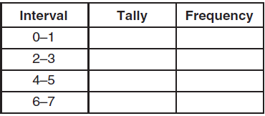

      - On the grid below, create a histogram based on the table you made.

Flip Over

      - Answer the following questions about the data distribution:

        - How many students played outside less than 4 days? __________

        - What does the shape of the histogram tell you about how much students play outside?

__________________________________________________________________________________________________

__________________________________________________________________________________________________

__________________________________________________________________________________________________

__________________________________________________________________________________________________

Author and Source Unknown. Achievement First does not own the copyright in “Independent Practice” and claims no copyright in this material. The material is being used exclusively for non-profit educational purposes under fair use principles in U.S. Copyright laws. The user should make the judgment about whether this material may be used under fair use / fair dealing permissions in the user’s country.

