Interaction with New Material

Ex. 1) Using the inequality below, write a real world context that describes the order of the numbers.
-5.25 < -1 < -0.5

__________________________________________________________________________________________

__________________________________________________________________________________________

__________________________________________________________________________________________

__________________________________________________________________________________________

__________________________________________________________________________________________

PARTNER PRACTICE

Bachelor Level

- Write a real-world context that describes the inequality: -5 < 4

____________________________________________________________________________________

____________________________________________________________________________________

____________________________________________________________________________________

____________________________________________________________________________________

____________________________________________________________________________________

- Given the comparison, -9 < -2, which statement would describe the inequality?

- -9 degrees Fahrenheit is warmer than -2 degrees
- A person at a depth of 9 feet is lower than a person at a depth of 2 feet
- Nine feet below sea level is higher than two feet below sea level
- A $9 debt is a lesser debt than a $2 debt

Explain the description you chose matches the inequality: _______________________

____________________________________________________________________________________

____________________________________________________________________________________

____________________________________________________________________________________

Master Level

- Given the order of the numbers from least to greatest, -4 ½, -2, 5 ½, which statement would best describe the order of numbers?

  - A 4½ meter decrease in altitude is a smaller change than a two meter decrease, which is smaller than a 5½ meter change.

  - A 4½ mm decrease in height is a smaller change than a 2 mm decrease, which is smaller than a 5½ mm increase.

  - -4½˚C is colder than -2˚C, which is colder than 5½˚C

  - 4½ feet below sea level is shallower than 2 feet below sea level, which is shallower than 5½ feet below sea level.

Explain the description you chose matches the inequality: _______________________

____________________________________________________________________________________

____________________________________________________________________________________

____________________________________________________________________________________

INDEPENDENT PRACTICE

Bachelor Level
- Write a real-world context that would describe the inequality: -2000> -3000

____________________________________________________________________________________

____________________________________________________________________________________

____________________________________________________________________________________

____________________________________________________________________________________

____________________________________________________________________________________

- Given the comparison, 12.4 < 14.9, which statement best describes the inequality?

- An altitude of 12.4 meters is higher than an altitude of 14.9 meters
- A depth of 12.4 feet is lower than a depth of 14.9 feet.
- An altitude of 12.4 meters is lower than an altitude of 14.9 meters
- A depth of 12.4 feet is higher than a depth of 14.9 feet

- Given the comparison, -6 > -12, which statement best describes the inequality?

- 6˚C is colder than 12˚C
- 6˚C is warmer than 12˚C
- -6˚C is colder than -12˚C
- -6˚C is warmer than -12˚C

Explain:

____________________________________________________________________________________

____________________________________________________________________________________

____________________________________________________________________________________

____________________________________________________________________________________

Master Level

- Which statement best describes the order of numbers: -20.5 > -40 > -40.1

- A hiker at an altitude of 20.5 feet is higher than a hiker at 40 feet who is higher than a hiker at 40.1 feet.

- A mole digging 20.5 cm underground is lower than a mole at 40 cm underground, which is lower than a mole at 40.1 feet underground

- A scuba diver swimming 20.5 feet below the surface is lower than someone swimming at 40 feet below, who is lower than someone swimming at 40.1 feet below.

- A submarine at 20.5 meters below the surface is higher than one at 40 meters below, which is higher than one at 40.1 meters below

- Given the order of numbers (-52, -44, 0, 25), write a real-world context to describe the order of numbers.

____________________________________________________________________________________

____________________________________________________________________________________

____________________________________________________________________________________

____________________________________________________________________________________

____________________________________________________________________________________

____________________________________________________________________________________
- Given the order of numbers (20.4, 21.9, 22.9), write a real-world context to describe the order of numbers.

____________________________________________________________________________________

____________________________________________________________________________________

____________________________________________________________________________________

____________________________________________________________________________________

____________________________________________________________________________________

____________________________________________________________________________________

PhD Level

- Kendra collected data for her Science project. She surveyed people asking them how many hours they sleep during a typical night. The chart below shows how each person’s response compares to 8 hours (which is the answer she expected most people to say). 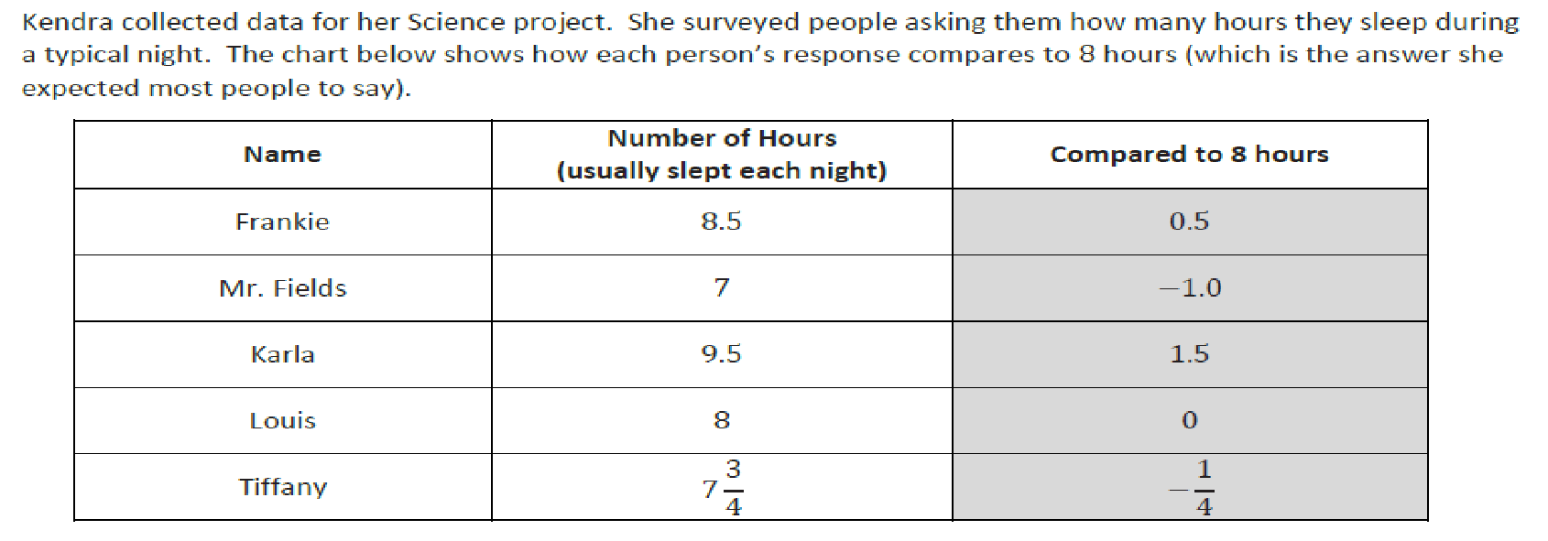
Will the order of the numbers in the third column be the same when the numbers are ordered from least to greatest and when they are ordered from the smallest difference from 8 hours to greatest difference from 8 hours? Explain how you know.

____________________________________________________________________________________

____________________________________________________________________________________

____________________________________________________________________________________

____________________________________________________________________________________

____________________________________________________________________________________

Name: ______________________________ Date: _______________________
EXIT TICKET
Self-assessment | I mastered the learning objective today. | I am almost there. | Need more practice and feedback.
Teacher feedback | You mastered the learning objective today. | You are almost there. | You need more practice and feedback.

- Given the comparison, -4.50 < 3.25, which statement would describe the inequality?

- A debt of $4.50 is a smaller debt than a debt of $3.25

- A fish swimming at 4.50 ft below the surface is lower than a bird flying at 3.25 feet above the surface.

- A loss of 4.50 yards is a greater distance than a gain of 3.25 yards

- A decrease of 4.50 meters in altitude is a larger change than a 3.25 meter increase.

- Given the order 200 > -100 > -150, write a real-world context that would describe the order of numbers.

____________________________________________________________________________________

____________________________________________________________________________________

____________________________________________________________________________________

____________________________________________________________________________________

Flip over for problem 3!
- Andréa and Marta are testing three different coolers to see which keeps the coldest temperature. They placed a bag of ice in each cooler, closed the coolers, and then measured the air temperature inside each after 90 minutes. The temperatures are recorded in the table below:

Cooler | A | B | C
Temperature (ᵒC) | -2.51 | 5.7 | -4.3

Marta wrote the following inequality statement about the temperatures:
−4.3 < −2.51 < 5.7.

Andréa claims that Marta made a mistake in her statement and that the inequality statement should be written as −2.51 < −4.3 < 5.7.

- Is either student correct? Explain

____________________________________________________________________________________

____________________________________________________________________________________

____________________________________________________________________________________

____________________________________________________________________________________

- The students want to find a cooler that keeps the temperature inside the cooler more than 2.5 degrees below the freezing point of water (0ᵒC) after 90 minutes. Indicate which of the tested coolers meets this goal and explain why.

____________________________________________________________________________________

____________________________________________________________________________________

____________________________________________________________________________________

____________________________________________________________________________________

