Name: ___________________________
CFS for top quality work
  - Constant of proportionality is calculated and annotated
  - Labels are identified on the graph (if applicable)
  - Equation is written as y=kx (if applicable)
Date: ____________________________
UNIT 5 LESSON 9

AIM: SWBAT interpret the meaning of points on a graphed proportional relationship.

THINK ABOUT IT!
Freddie is walking for a charity. After two hours, Freddie has walked 4 miles. At 4 hours, he had walked 8 miles.
Part A: Graph the relationship between how far Freddie walks and how long it takes him.
Part B: Determine the CoP
Part C: Circle on the graph where the CoP is represented.

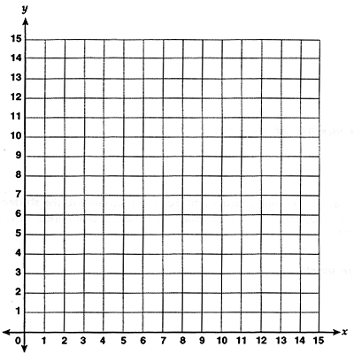

CoP: _________________

Test the Conjecture #1) The graph below represents how much money Marcia charges for babysitting a certain number of hours. Explain the meaning of the point (1,15) and why the point (0,0) appears on the graph.
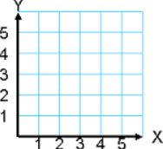
_____________________________________________________________________________________________________________________________________________________________________________________________________________________________________________________________________________________________________________________________________________________________________________________________________________________

Price
5 10 15 20 25 30

1 2 3 4 5 6
Hours

Test the Conjecture #2) The graph shows the amount of gas used by a moped that travels a certain number of miles. Will the point (15,90) be on the graph of the line?
CFS for top quality work
  - Constant of proportionality is calculated and annotated
  - Labels are identified on the graph (if applicable)
  - Equation is written as y=kx (if applicable)

Miles

Gallons

Conjecture
When x=1, ______ is the constant of proportionality for a proportional relationship.
PARTNER PRACTICE
CFS for top quality work
  - Constant of proportionality is calculated and annotated
  - Labels are identified on the graph (if applicable)
  - Equation is written as y=kx (if applicable)

Bachelor Level

Use the graph to answer questions 1-4
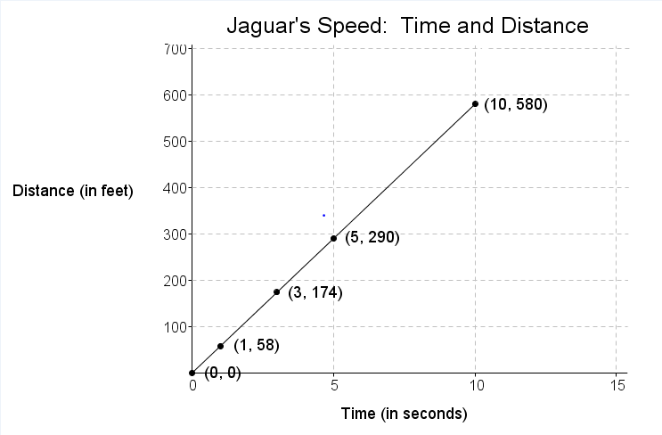

- What does the point (5, 290) represent in the context of the situation?

______________________________________________________________________________________________________________________________________________________________________________

- What does the point (3, 174) represent in the context of the situation?

______________________________________________________________________________________________________________________________________________________________________________

- What is the constant of proportionality of and what does it represent in the context of the situation?

______________________________________________________________________________________________________________________________________________________________________________

- Explain why the point (0,0) is a part of the graph.

______________________________________________________________________________________________________________________________________________________________________________
Master Level

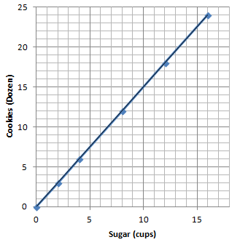
- The graph below shows the amount of sugar used to make cookies.

Part A: Can the CoP be determined just by looking at the graph? Why? Why not?

___________________________________________________

___________________________________________________

___________________________________________________

Part B: What is the CoP for the graph?

Part C: Which point(s) below would fall on the line? Select all that apply.

a) (1, 1.5)

b) (20, 21.5)

c) (20, 30)

d) (30, 20)

INDEPENDENT PRACTICE

CFS for top quality work
  - Constant of proportionality is calculated and annotated
  - Labels are identified on the graph (if applicable)
  - Equation is written as y=kx (if applicable)

Bachelor Level

Use the graph to answer questions 1 – 4
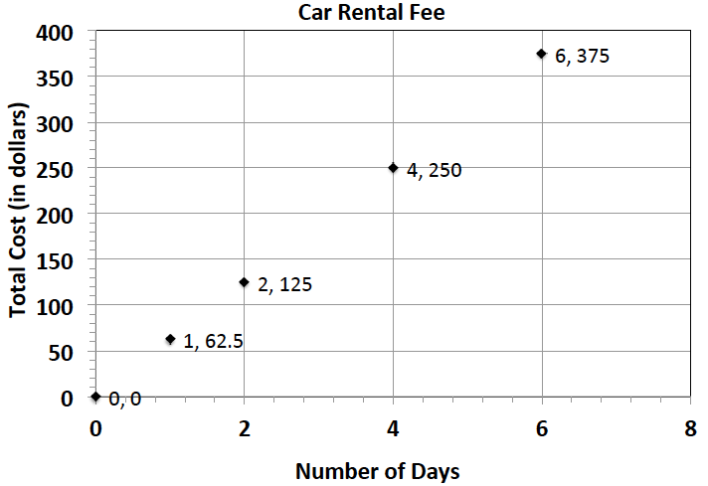
- What does the ordered pair (4, 250) represent?

____________________________________________________
____________________________________________________
____________________________________________________
____________________________________________________

- Does the graph represent a proportional relationship? How do you know?

________________________________________________________________________________________________________________________________________________________________________________________________________________________________________________________________________________________________________________________________________________________________________________________

- What would be the cost to rent a car for a week? Explain

___________________________________________
Master Level

- Jackie is making a snack mix for a party. She is using cashews and peanuts. The table below shows the relationship of the number of packages of cashews she needs to the number of cans of peanuts she needs to make the mix.
Packages of Cashews | Cans of Peanuts
$$0$$ | $$0$$
$$1$$ | $$2$$
$$2$$ | $$4$$
$$3$$ | $$6$$
$$4$$ | $$8$$

Step A: Write an equation to represent this relationship.

Step B: Describe the ordered pair $(12, 24)$ in the context of the problem.

____________________________________________________________________________________________________________________________________________________________________________________________

Step C: Label and graph the relationship and identify the constant of proportionality by labeling it on the graph.
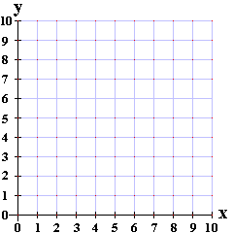

Step D: Would the point (39, 79) appear on the graph? Why or why not?

____________________________________________________________________________________________________________________________________________________________________________________________

Step E: What value of r would make it so that the point (r, 25) would appear on the line?

- A car fills up its entire gas tank for $22.
  - What point(s) must be on the graph for the quantities to be proportional to each other?

________________________________________________________________________________________________________________________________________________________________________________

  - What does the ordered pair (5, 110) represent in the context of the problem?

________________________________________________________________________________________________________________________________________________________________________________

  - How many times could you fill up your car for $88?

  - Why does the point (0,0) appear on the graph?

________________________________________________________________________________________________________________________________________________________________________________

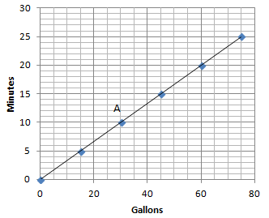
- The graph to the right shows the number of gallons someone uses to shower for a certain amount of time.

  - Can you determine by looking at the graph what the constant of proportionality is? Why or why not?

__________________________________________________
__________________________________________________
__________________________________________________
__________________________________________________

  - How long can a person shower and only use 15 gallons of water?

  - What does the ordered pair at point A represent in the context of the situation?

PhD Level

- The following table shows the amount of candy and price paid.
Amount of Candy (in pounds) | $$2$$ | $$3$$ | $$5$$
Cost (in dollars) | $$5$$ | $$7.5$$ | $$12.5$$

  - Is the cost of the candy proportional to the amount of candy?

________________________________________________________________________________________________________________________________________________________________________________

  - Write an equation to illustrate the relationship between the amount of candy and the cost.

  - Using the equation, predict how much it will cost for $12$ pounds of candy.

  - What is the maximum amount of candy you can buy with $\$60$?

  - Label and graph the relationship. Annotate the constant of proportionality on the graph.

Name: ______________________________
CFS for top quality work
  - Constant of proportionality is calculated and annotated
  - Labels are identified on the graph (if applicable)
  - Equation is written as y=kx (if applicable)

Date: _______________________

EXIT TICKET
Self-assessment | I mastered the learning objective today. | I am almost there. | Need more practice and feedback.
Teacher feedback | You mastered the learning objective today. | You are almost there. | You need more practice and feedback.

- Great Rapids White Water Rafting Company rents rafts for $125 per hour. Explain why the point (0, 0) and (1, 125) would be on the graph of the relationship and what these points mean in the context of the problem.

____________________________________________________________________________________________________________________________________________________________________________________________________________________________________________________________________________________________________________________________________________________________________________________________________________________________________________________________________________________________________________________________________________________________________________________

- Would the point (5, 625) appear on the graph of this relationship? Why? What does this point represent in the context of the problem?

____________________________________________________________________________________________________________________________________________________________________________________________________________________________________________________________________________________________________________________________________________________________________________________________________________________________________________________________________________________________________________________________________________________________________________________

