Name: ___________________________ Date: ____________________________

UNIT 8 LESSON 9

|  |  |
| --- | --- |
| AIM: | SWBAT solve area problems involving compound figures on coordinate grids |

**THINK ABOUT IT!**

Determine the area of the figure drawn on the coordinate grid below. Explain the strategy that you used to determine the area of the figure.

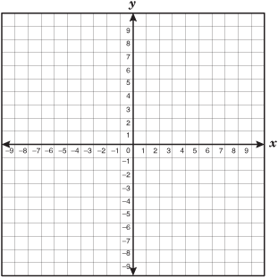

Key Point

|  |
| --- |
| Area of compound figures can be found using ___________________ |

**Interaction with New Material**

*Ex. 1)* Plot the points on the coordinate grid below to form pentagon PQRST.

P (1, -4), Q (5, -2), R (9, -4), S (7, -8), and T (3, -8)



* **CFS for top quality work**
  + Problem is annotated
  + Figure is drawn accurately (as needed)
  + Figure is **decomposed** and dimensions are labeled
  + **Formulas** are written
  + All calculations are shown, /answer statement is written

What is the figure’s area?

**PARTNER PRACTICE**

|  |
| --- |
| *Bachelor Level* |

1. Determine the area of the figure drawn on the grid below



* **CFS for top quality work**
  + Problem is annotated
  + Figure is drawn accurately (as needed)
  + Figure is **decomposed** and dimensions are labeled
  + **Formulas** are written
  + All calculations are shown, /answer statement is written

Area: ______________________________

What is the perimeter of the figure?

Perimeter: __________________________

|  |
| --- |
| *Master Level* |

1. Measure the area of the figure on the coordinate plane below.



* **CFS for top quality work**
  + Problem is annotated
  + Figure is drawn accurately (as needed)
  + Figure is **decomposed** and dimensions are labeled
  + **Formulas** are written
  + All calculations are shown, /answer statement is written

**INDEPENDENT PRACTICE**

|  |
| --- |
| *Bachelor Level* |

1. Graph the points below on the coordinate plane. Connect the points with line segments in the order that you graphed them. Then, find the area of the figure you created.

**A(-9, 1) B(-9, 9) C(-6, 9) D(-6, 5) E(-2, 5) F(-2, 1)**



* **CFS for top quality work**
  + Problem is annotated
  + Figure is drawn accurately (as needed)
  + Figure is **decomposed** and dimensions are labeled
  + **Formulas** are written
  + All calculations are shown, /answer statement is written

|  |
| --- |
| *Master Level* |

1. Measure the area of the figure on the coordinate plane below.



* **CFS for top quality work**
  + Problem is annotated
  + Figure is drawn accurately (as needed)
  + Figure is **decomposed** and dimensions are labeled
  + **Formulas** are written
  + All calculations are shown, /answer statement is written

1. Measure the area of the figure on the coordinate plane below.



|  |
| --- |
| *PhD Level* |

1. Shon is redesigning the basement of his house. He drew a sketch of the floor plan for the basement below (each square represents one square foot).



He is working on deciding which type of flooring he will install in the basement. Based on the options below, how much will he save by going with the cheapest option over the most expensive option?

* + - Hardwood Floor: $14.99 per square foot and $299.99 installation fee
    - Tile Floor: $10.99 per square foot and $350.99 installation fee
    - Cement Floor: $19.99 per square foot and $199.99 installation fee

**Name: ______________________________ Date: _______________________**

**EXIT TICKET**

|  |  |  |  |
| --- | --- | --- | --- |
| Self-assessment | I mastered the learning objective today. | I am almost there. | Need more practice and feedback. |
| Teacher feedback | You mastered the learning objective today. | You are almost there. | You need more practice and feedback. |

1. Determine the area of the figure below. Show your work.

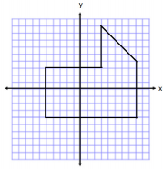

* **CFS for top quality work**
  + Problem is annotated
  + Figure is drawn accurately (as needed)
  + Figure is **decomposed** and dimensions are labeled
  + **Formulas** are written
  + All calculations are shown, /answer statement is written